

**Hands-On Lab**

**z/OS Operator Consoles**

## Abstract:

The z/OS Management Facility (z/OSMF) provides a web-based graphical interface for system programmers on z/OS. This hand on lab will give an opportunity to learn about the functions and features in z/OSMF first-hand. Attendees can navigate through the z/OS Operator Consoles task to see system messages and to issue system commands.

This session will be useful to systems programmers and their managers who will be using (or are considering using) the z/OS Management Facility.

## 

## 

## Introduction to z/OS Operator Consoles:

The z/OS Operator Consoles task lets you work with z/OS consoles. You can view system messages and issue system commands. The systems that you can work with are defined within the z/OSMF Systems task.

## Key features of the z/OS Operator Consoles Task

With the z/OS Operator Consoles task, you can:

* **Use the Overview tab to see the local sysplex and systems that are available for the z/OS Operator Consoles function.**
* **View system messages for a system or local sysplex. The Console Summary Viewer provides a graphical view of activity. Each bar in the graph represents a unit of time, so higher bars represent more activity. The colors in the bars reflect the colors of the messages that are displayed in the console. Hover the mouse pointer over the summary view to display additional information for that unit of time.**
* **Issue system commands** Type a system command or select a command from your command history. The command is issued to the local system, which is indicated in the text for the command line. To issue a command to another system, use a ROUTE command. Click Submit or press Enter, then get command response from web browser.
* **Retrieve historic messages from OPERLOG or SYSLOG.**

**z/OS Operator Consoles Lab**

This lab consists of 12 tasks.

1. Log on to z/OSMF
2. Complete setup
3. Start Console, and open console panel
4. View system messages for a system or local sysplex
5. Association between message bar and messages
6. Hide/Show summary view
7. Show/Hide WTOR and HOLD messages
8. Enter system commands
9. Lock/Resume console
10. Search with keywords
11. Filter messages
12. Retrieve historic messages from SYSLOG

It is recommended that you execute these tasks in the order listed above. As you get familiar with the z/OS Operator Consoles, you will be able to work directly with the task you need to accomplish.

As with all the labs in this session, all the teams will be working with the same z/OSMF System. Each team will be given a unique id to work with, please make sure you work with the user id assigned to your team to avoid confusing the other teams.

Notes:

Do NOT use the Browser BACK button to go to the prior screen.

* 1. Logon to z/OSMF
* Launch browser from your workstation
* Point browser to z/OSMF – enter the following url

<https://share.centers.ihost.com/zosmf>

* Login with SHARE userid/pw as provided by the lab instructor
* Each workstation has been assigned a unique z/OS user id

Note: All screen captures in the handout show the ID SHARA04, your browser will be slightly different to reflect the User ID that you were given.

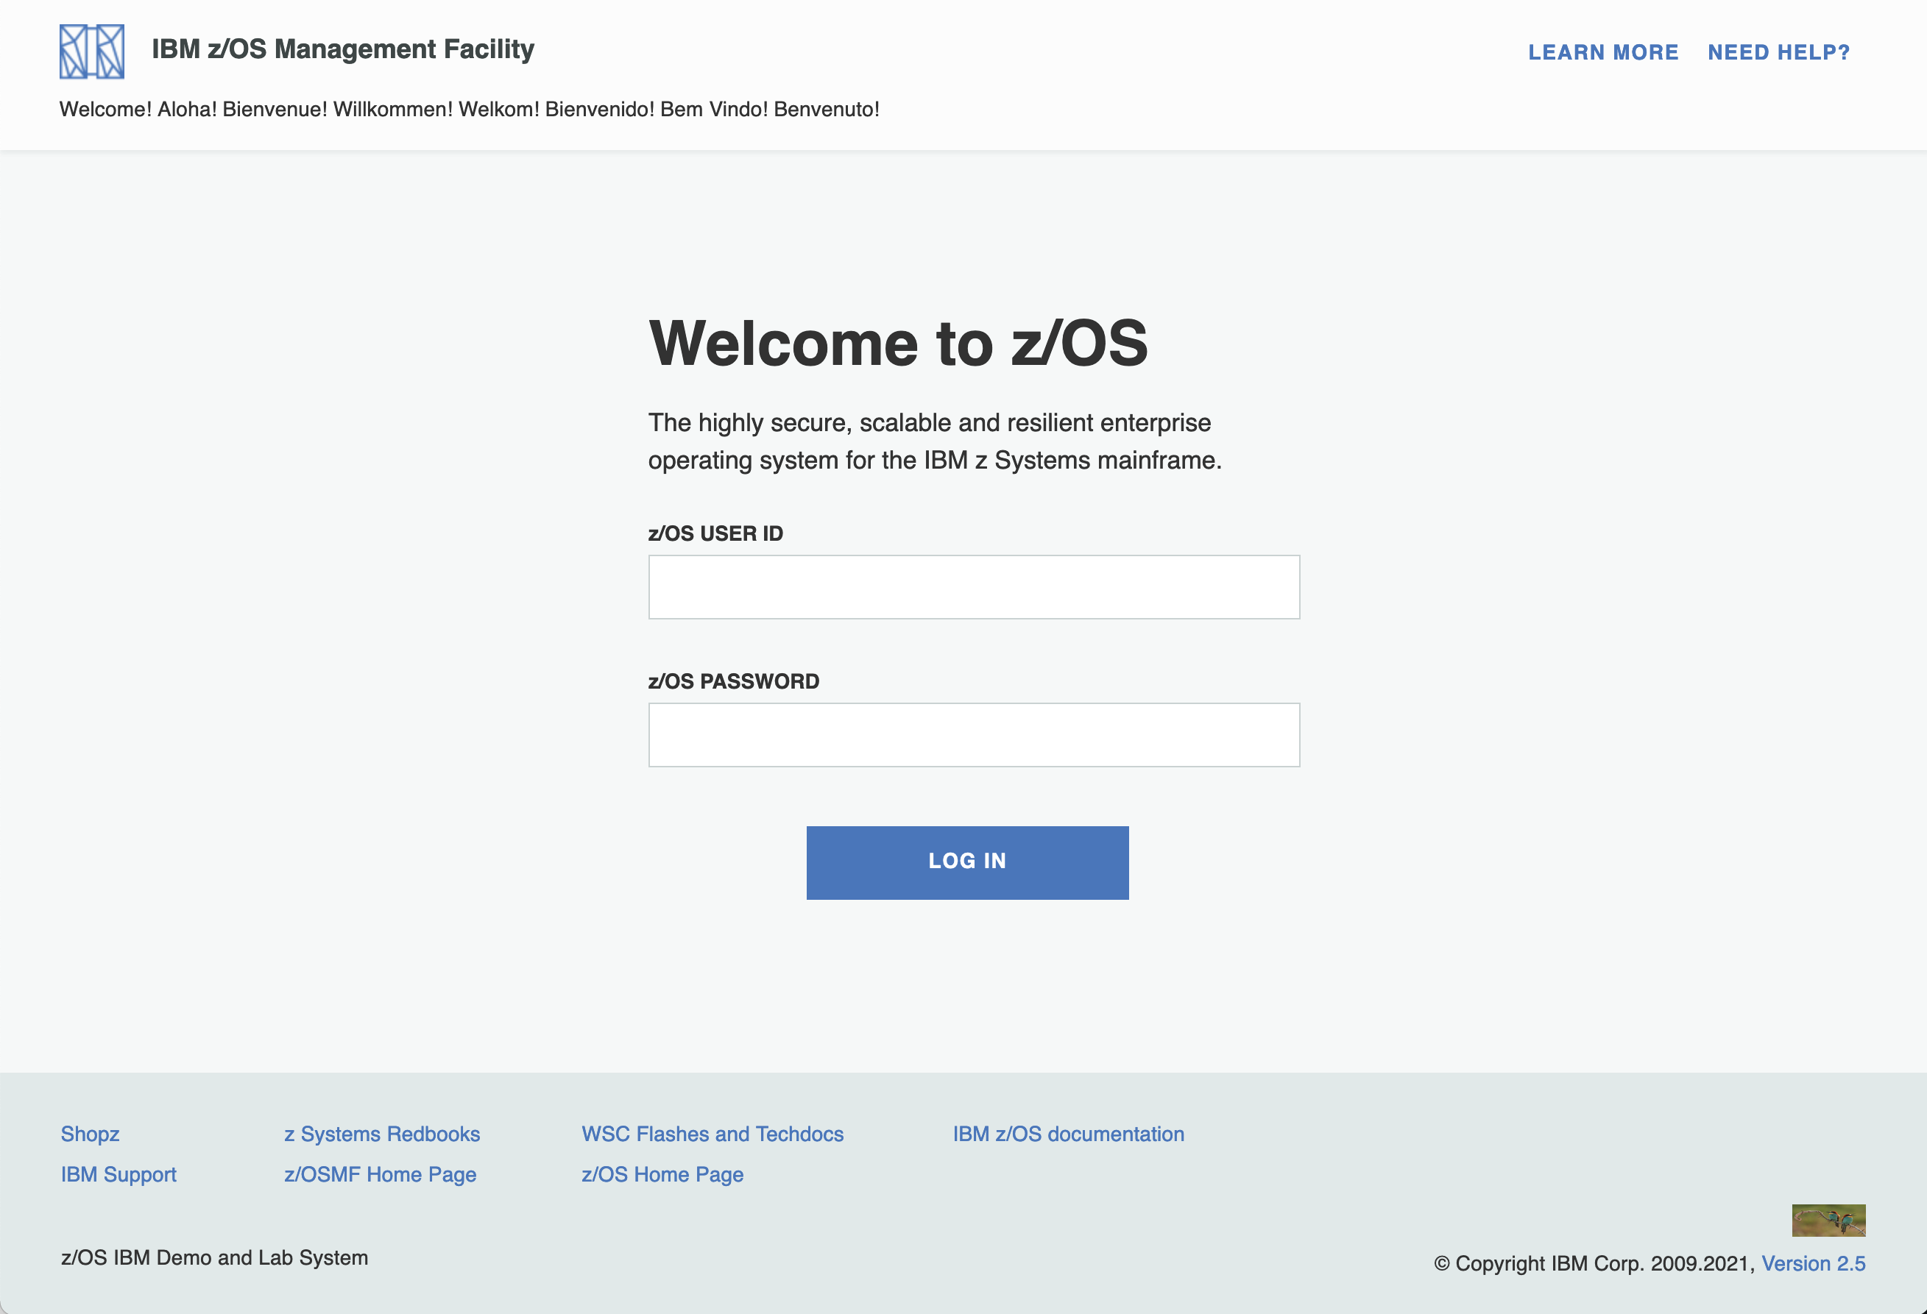

* 1. Complete setup

Step 2a: Double click z/OS Operator Consoles on Desktop

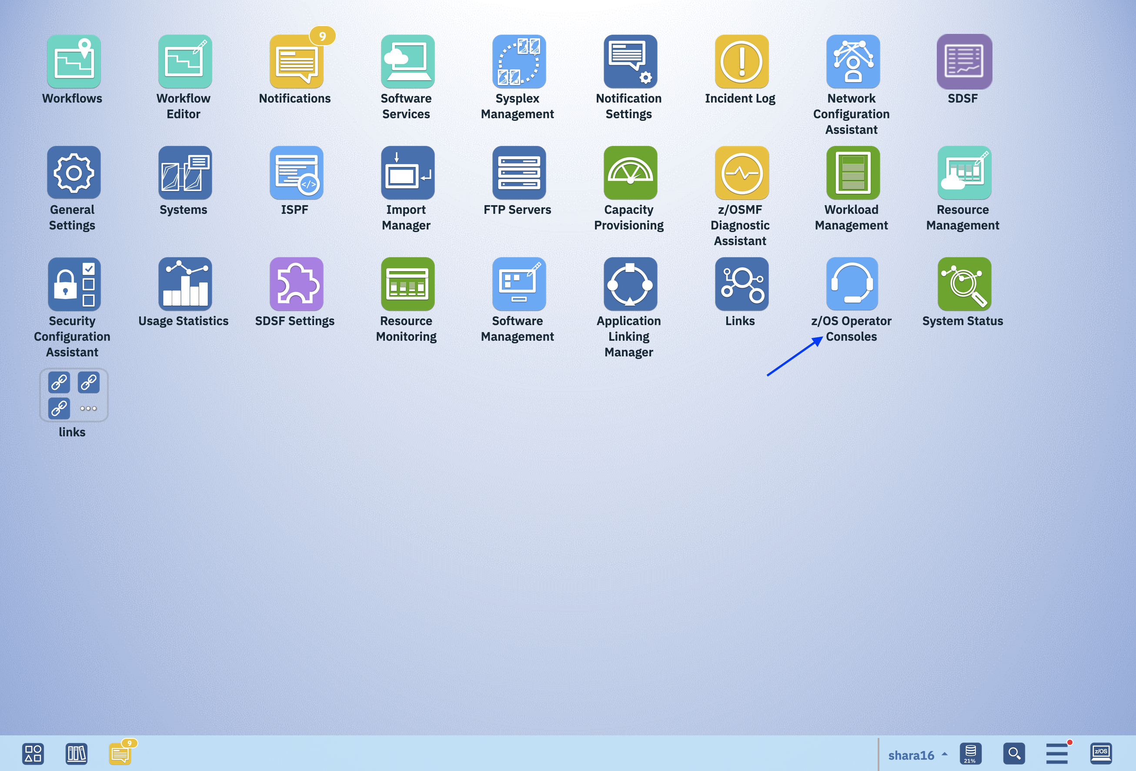

Step 2b: Select z/OS Operator Consoles window

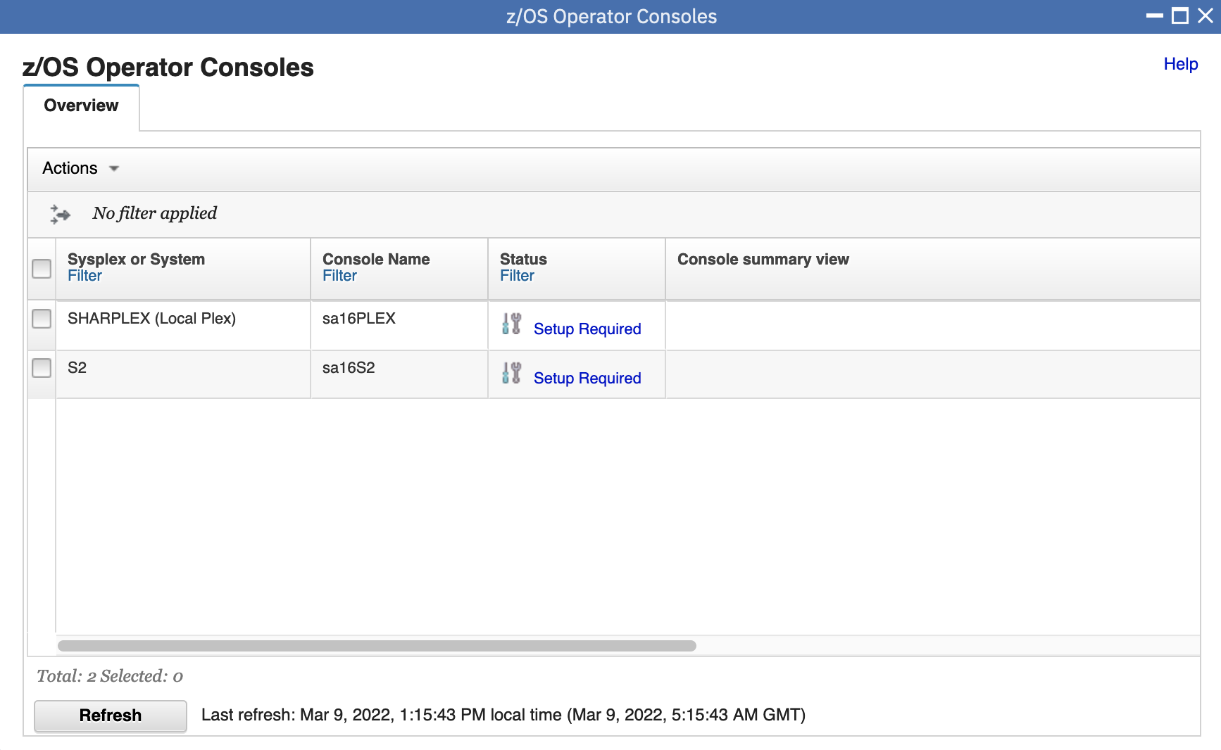

Step 2c: Select system S2

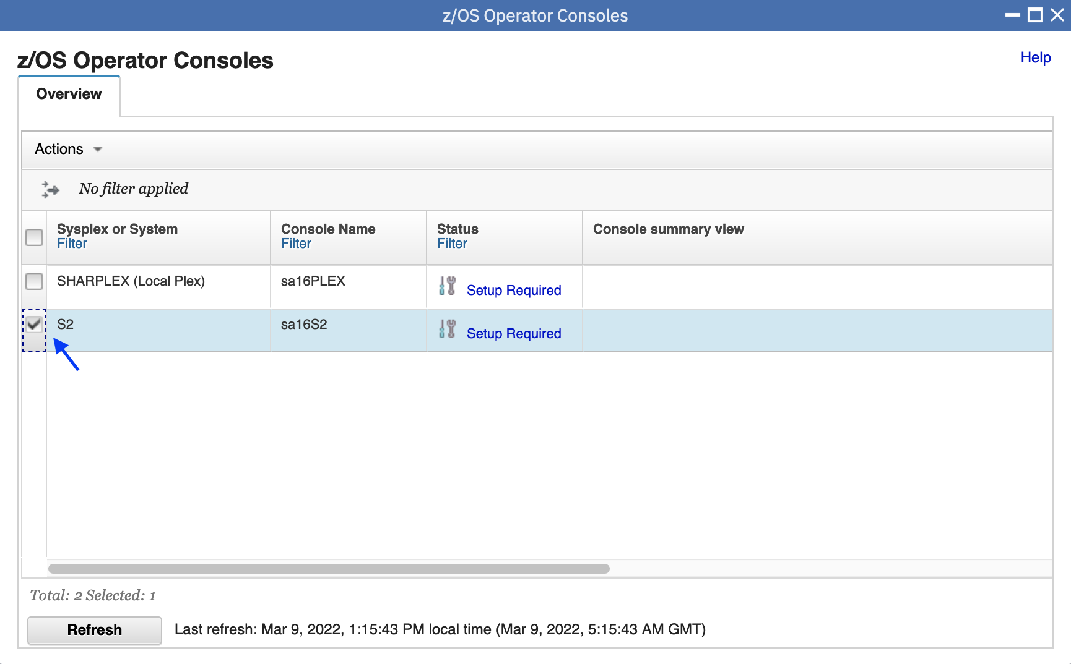

If you find the “Status” column in your table has already been “Setup Complete”, please skip the rest child steps of Step 2 and directly go to Step 3.

Step 2d: click Actions → Complete setup

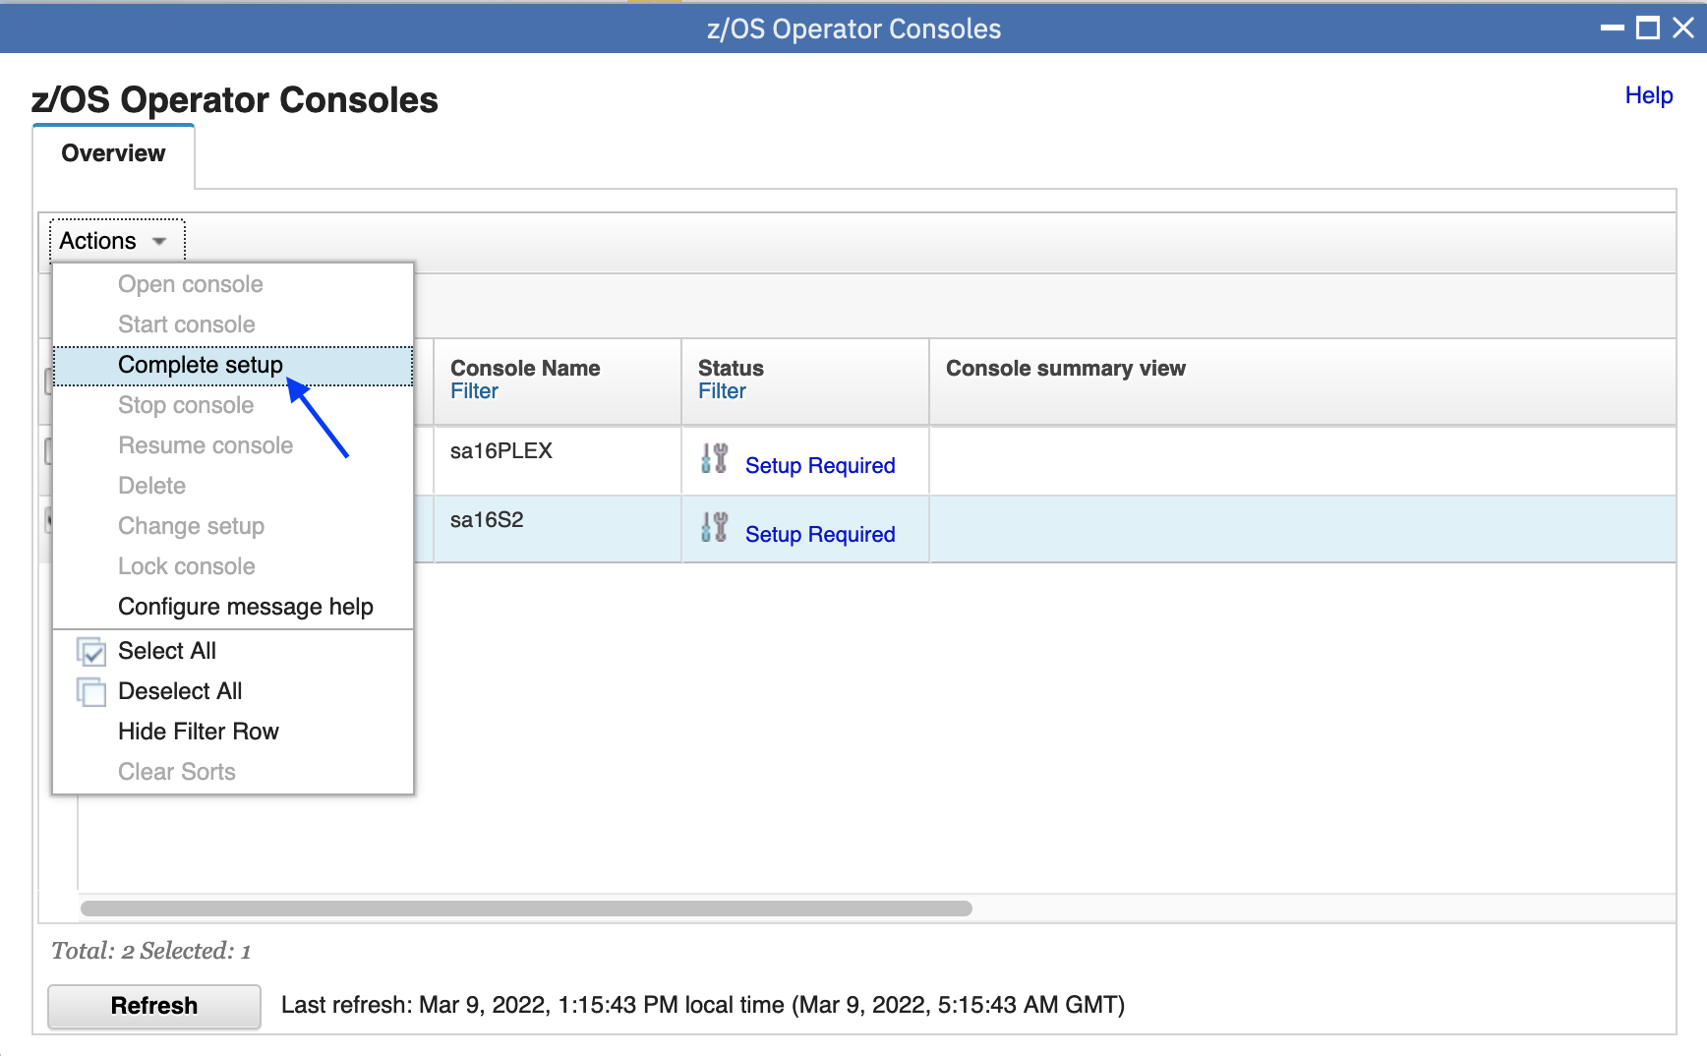

Step 2e: Keep the default value of EMCS console name (for SHARAnn userids it is SAnnS2, for SHARBnn userids it is SBnnS2, for SHARCnn userids it is SCnnS2).

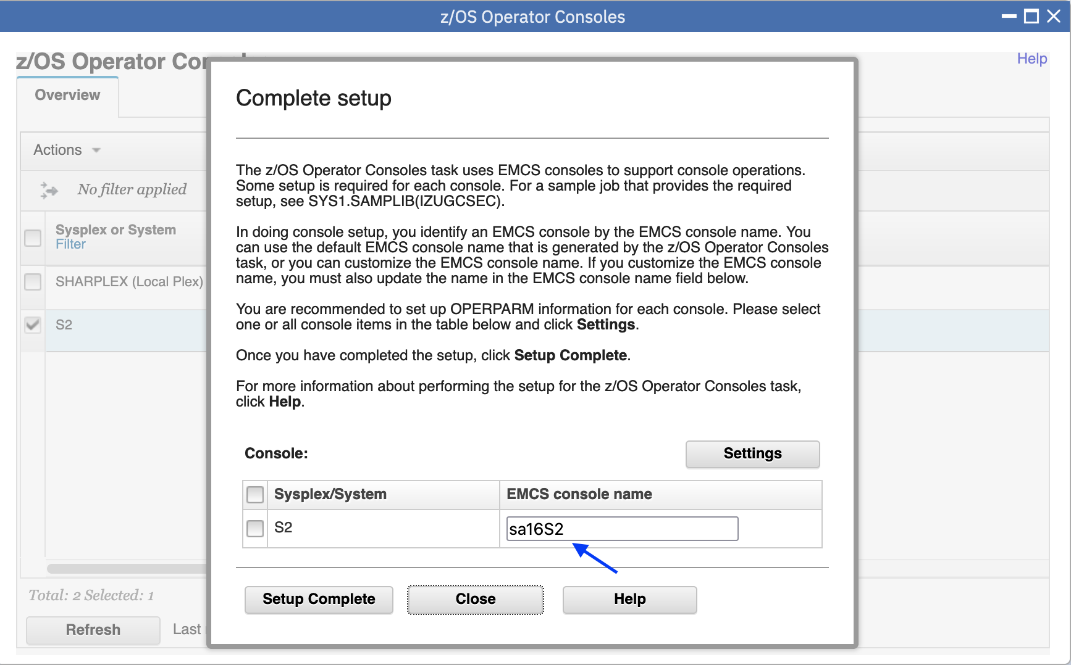

Notes: We have setup the permission for accessing the EMCS console “SxnnS2” for the user SHARxnn, if you need to modify the EMCS console name, it requires the administrator to proper setup.

Step 2f: After validating that the EMCS console name is correct for your assigned userid, Check the checkbox before S2, then click Settings button to open console settings page.

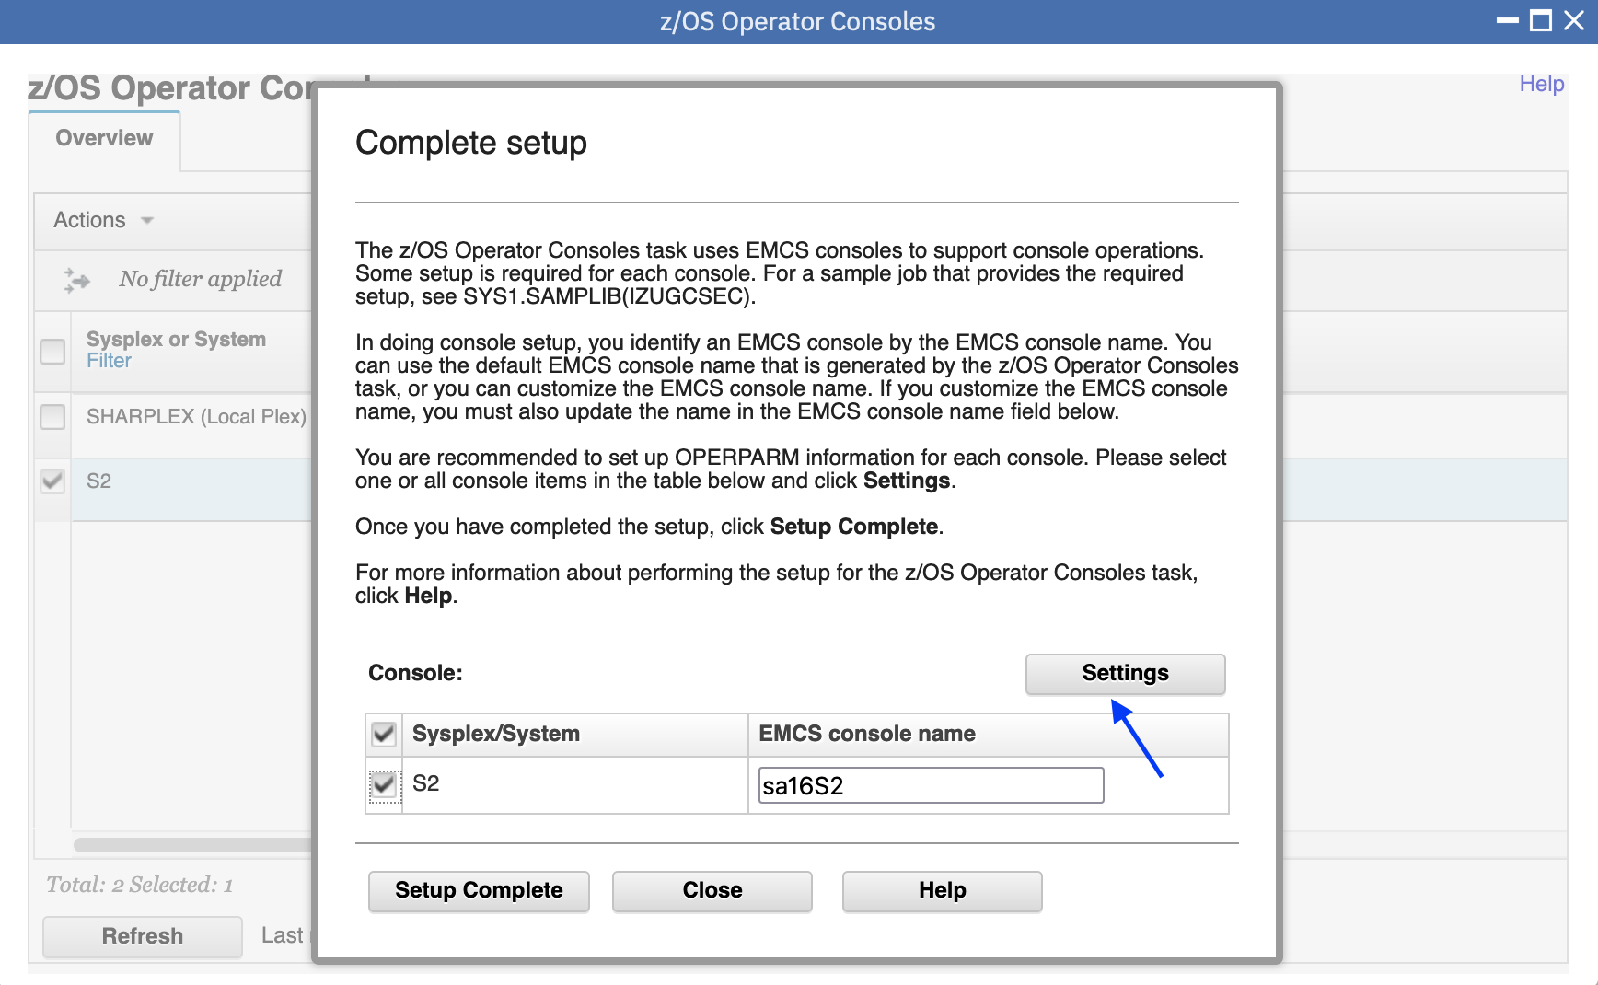

Step 2g: Click the drop list to set the OPERPARM values one by one, or check the “Use recommended values” to auto fill all the OPERPARM values. Then click OK button.

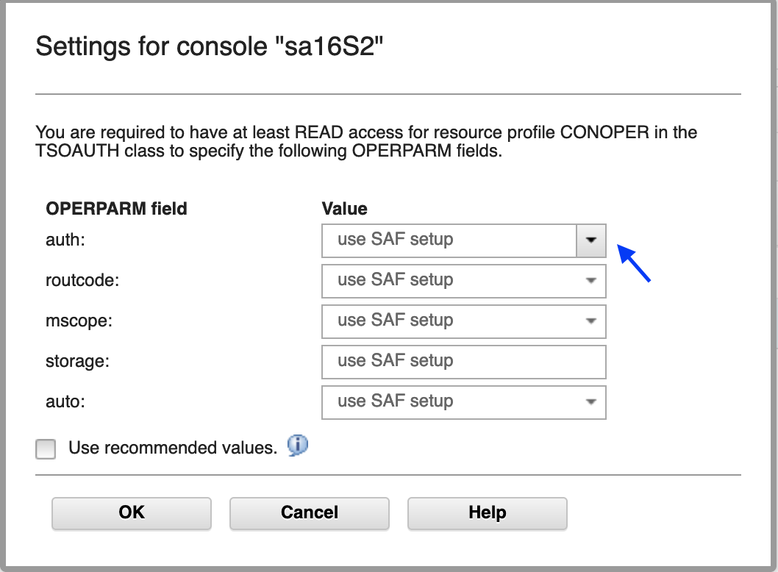

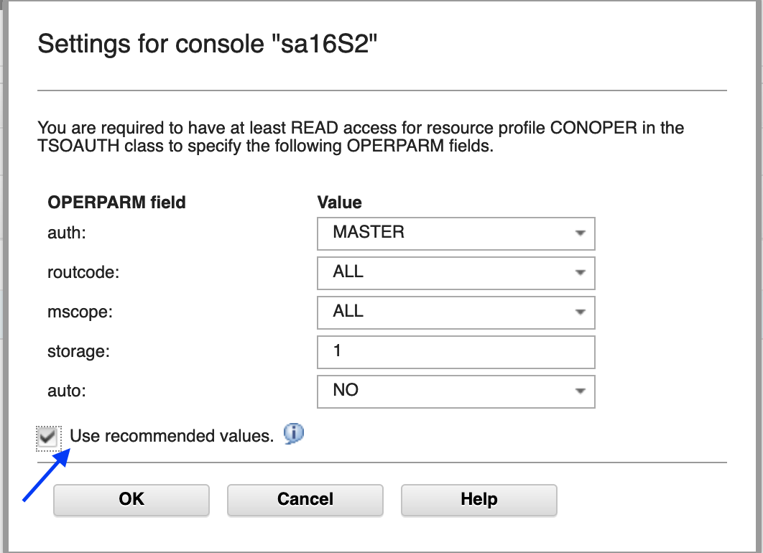

**Step 2h: Click Setup Complete button**

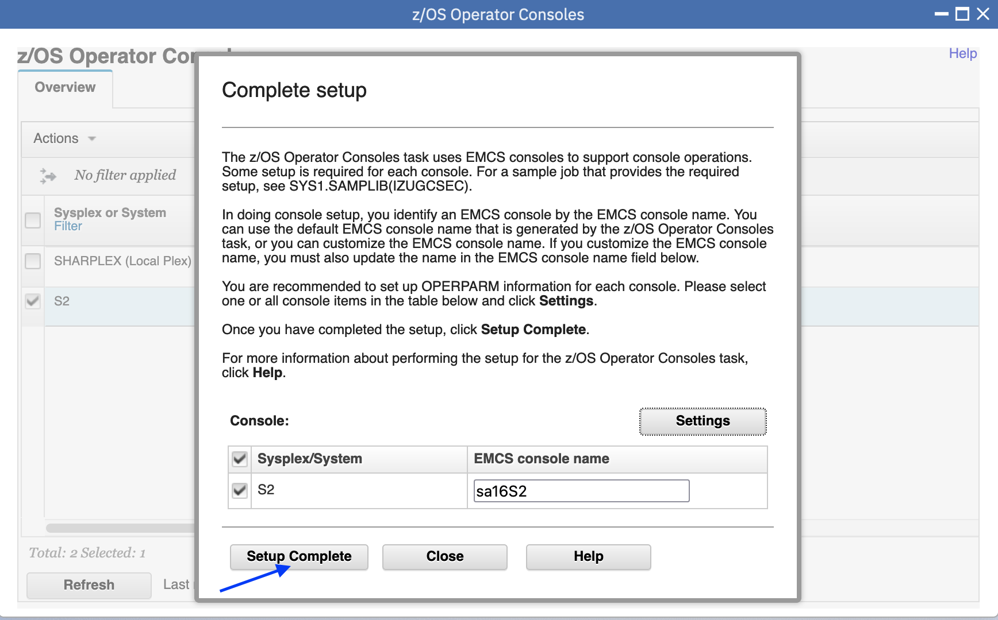

**Step 2i: The status of S2 is Setup Complete**

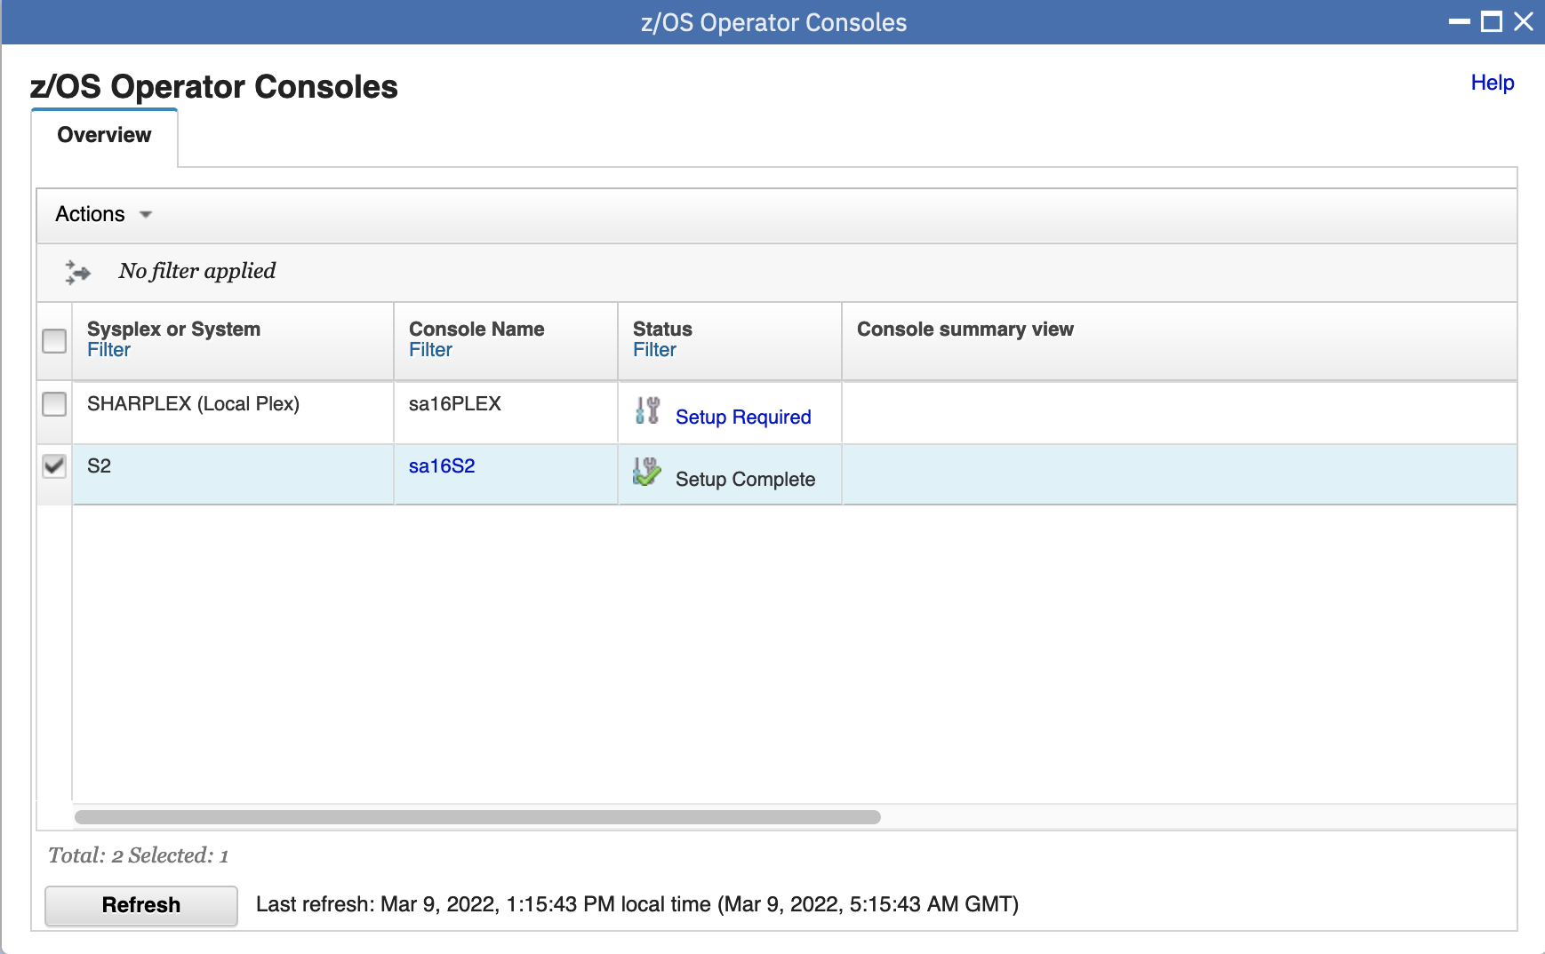

* 1. Start Console and open console panel

Step 3a: Select S2, click Actions-> Start Console

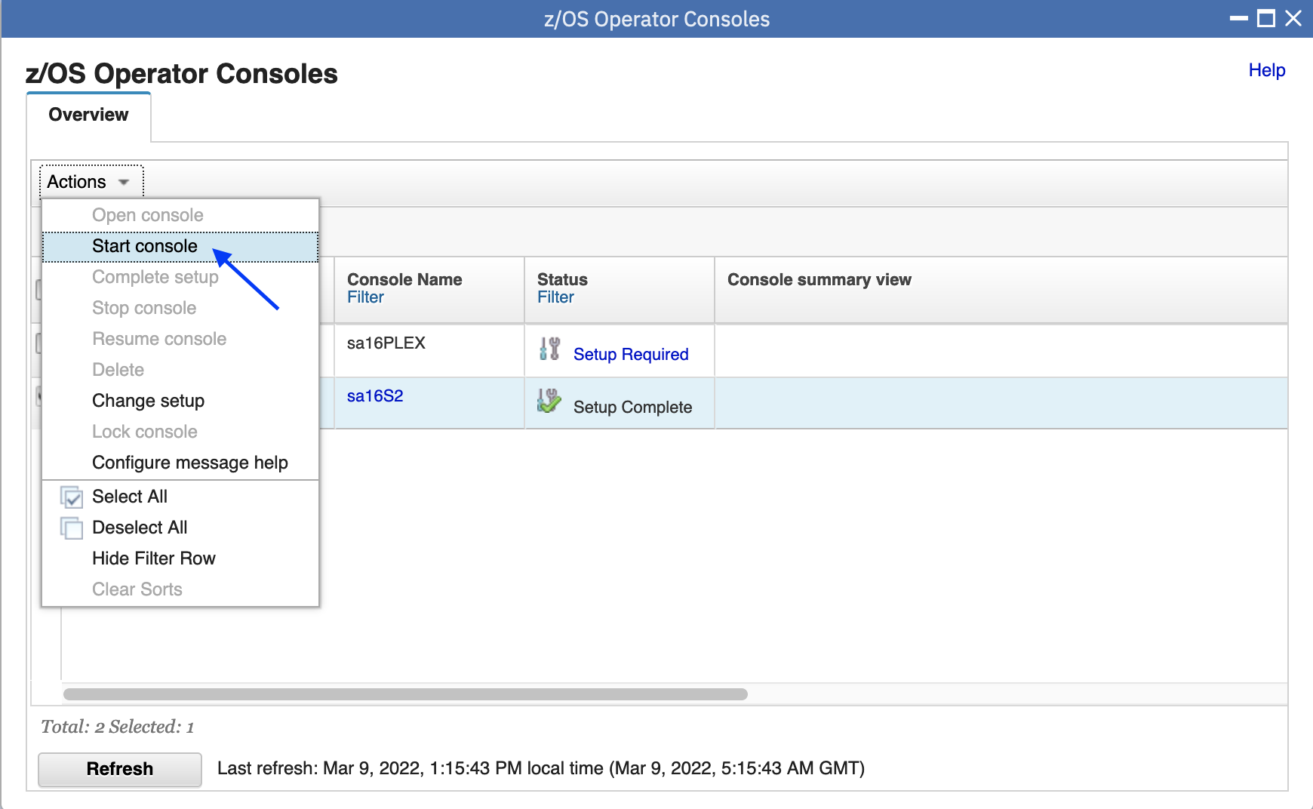

Step 3b: The status of S2 is Connected and S2 is clickable, Console Name SxnnS2 is also clickable to display settings of the console.

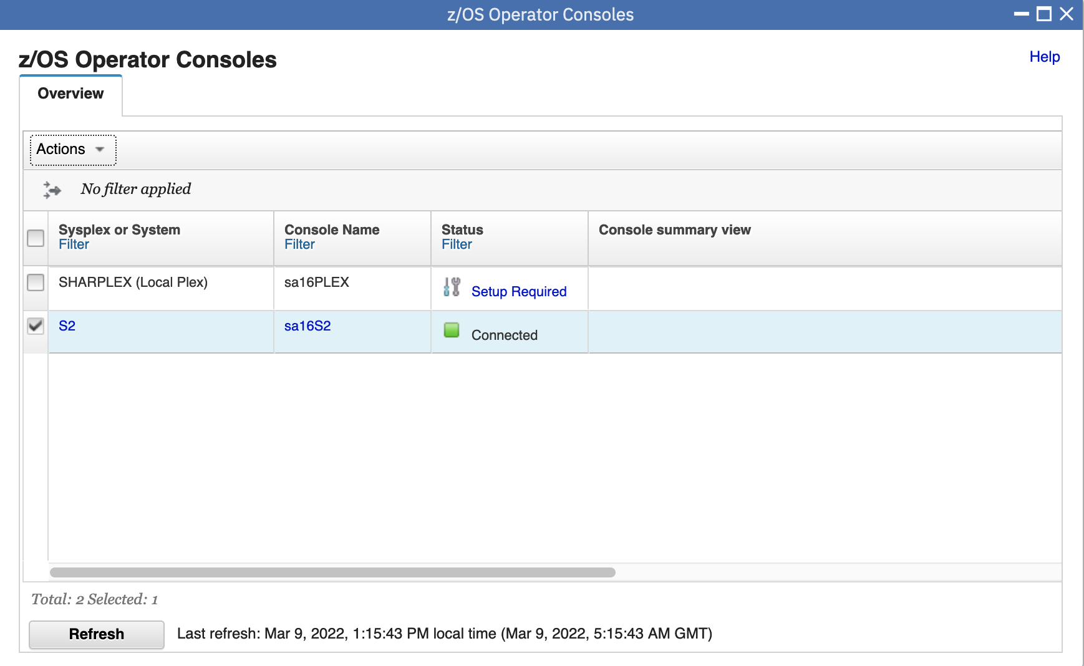

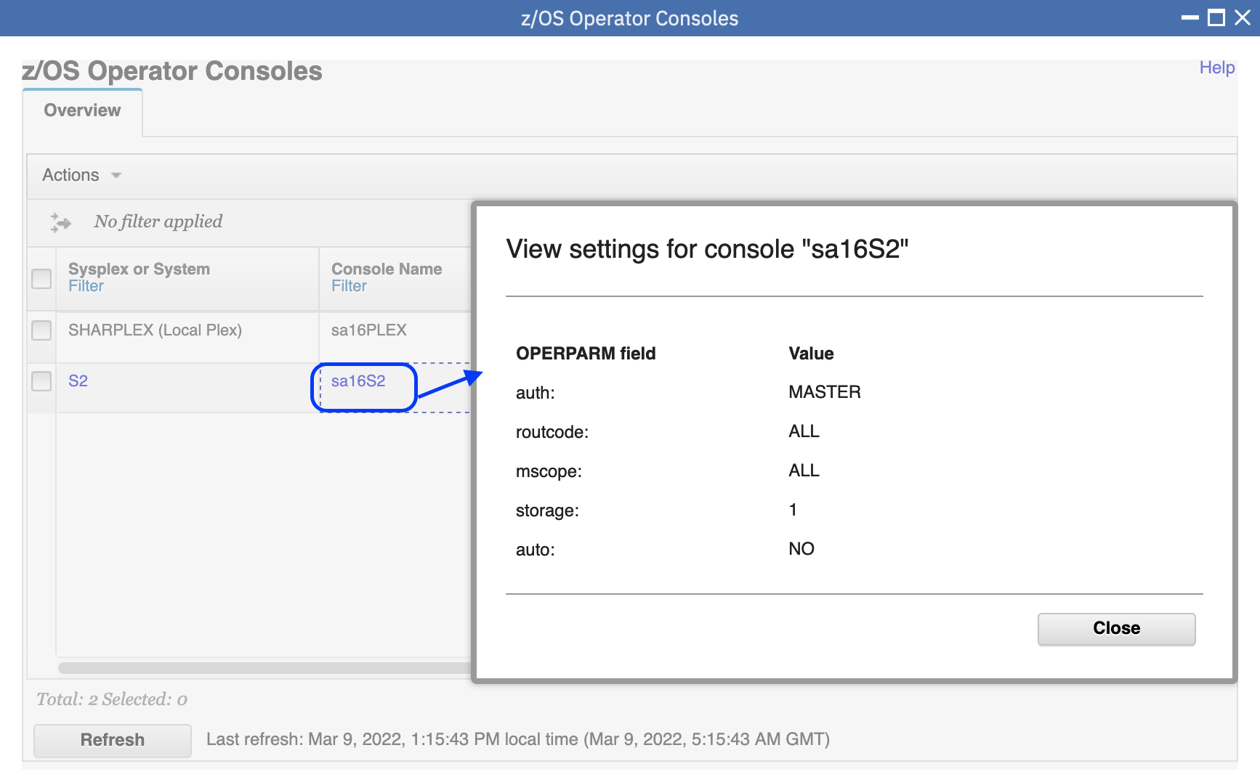

Step 3c: Click on the system name “S2”, the console for S2 will be opened in a new tab

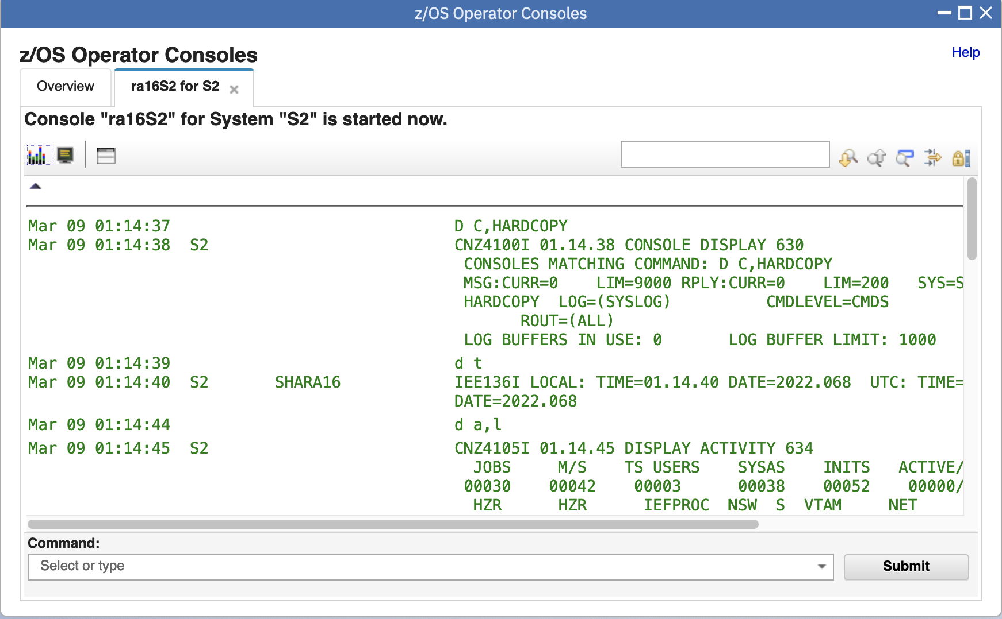

* 1. View system messages for a system or local sysplex

Step 4a: The console messages will be displayed in the Console panel over time. If you don’t see a lot of messages, that is fine. This system may not currently have many messages due to low workload.

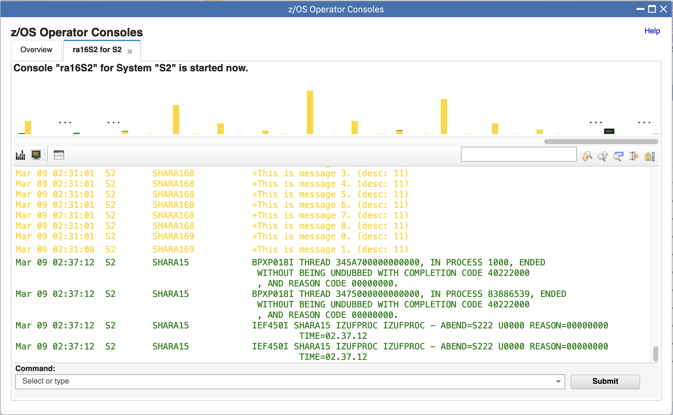

Step 4b: The message bars will be displayed in console summary view over time.

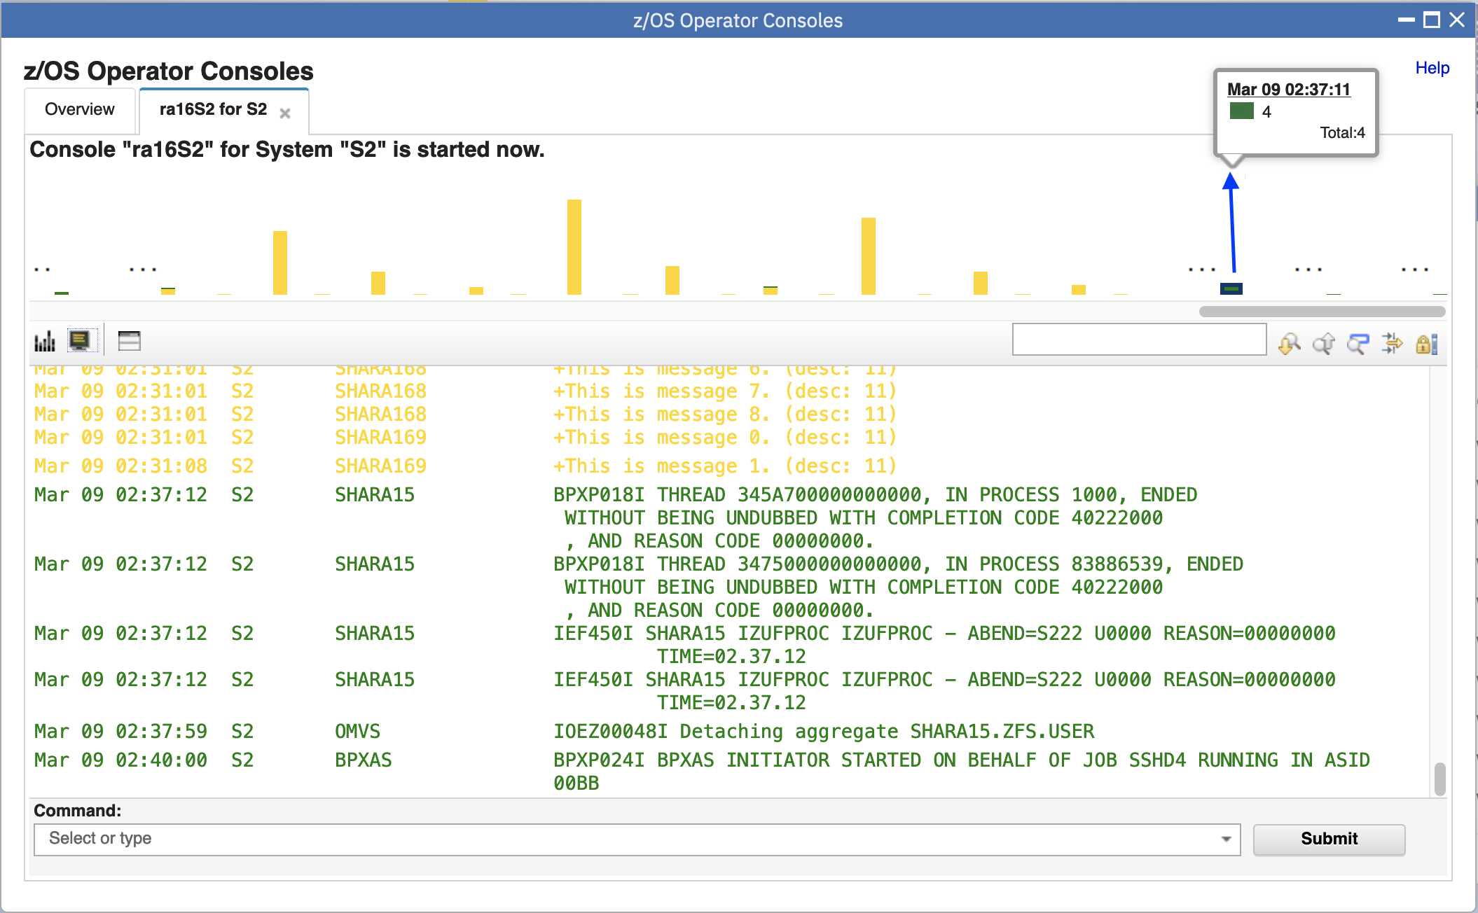

* 1. Association between message bar and messages

Step 5a: Click a specific message bar and the console window below will automatically scroll to the first message associated with the message bar.

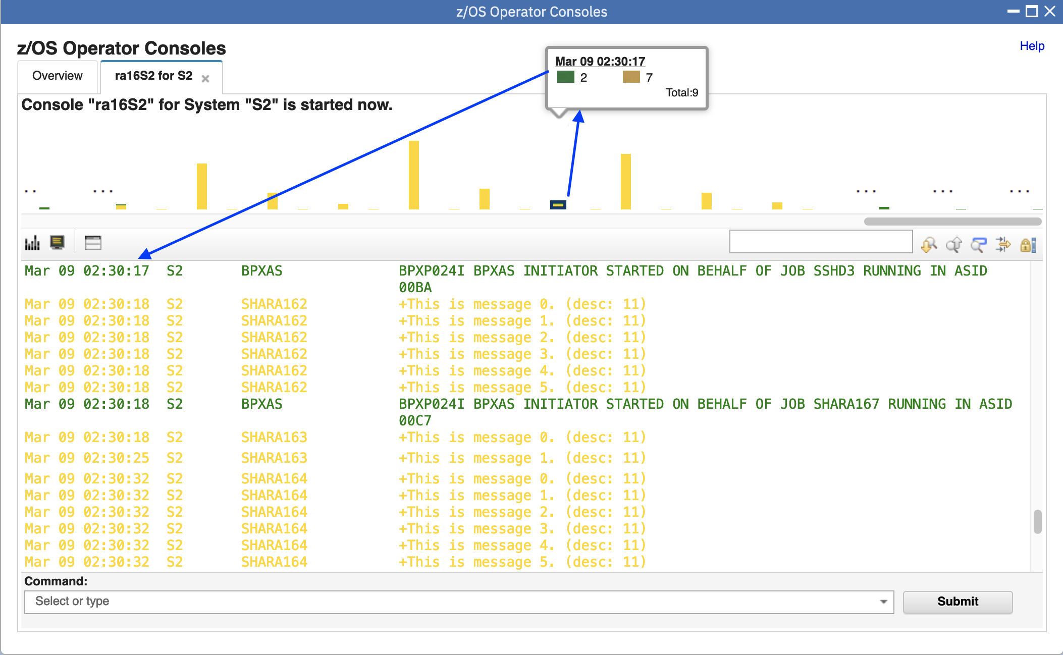

Step 5b: Click date time column of message in the Console Window, the message bar which the selected message belongs to will be highlighted in the console summary view

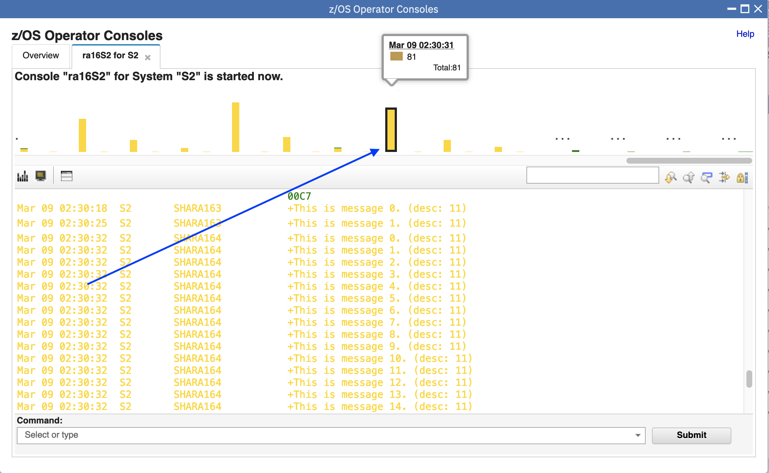

* 1. Hide/Show summary view

Step 6a: Click Hide summary view (tiny little bar box on the tool bar), the console summary view will be hidden.

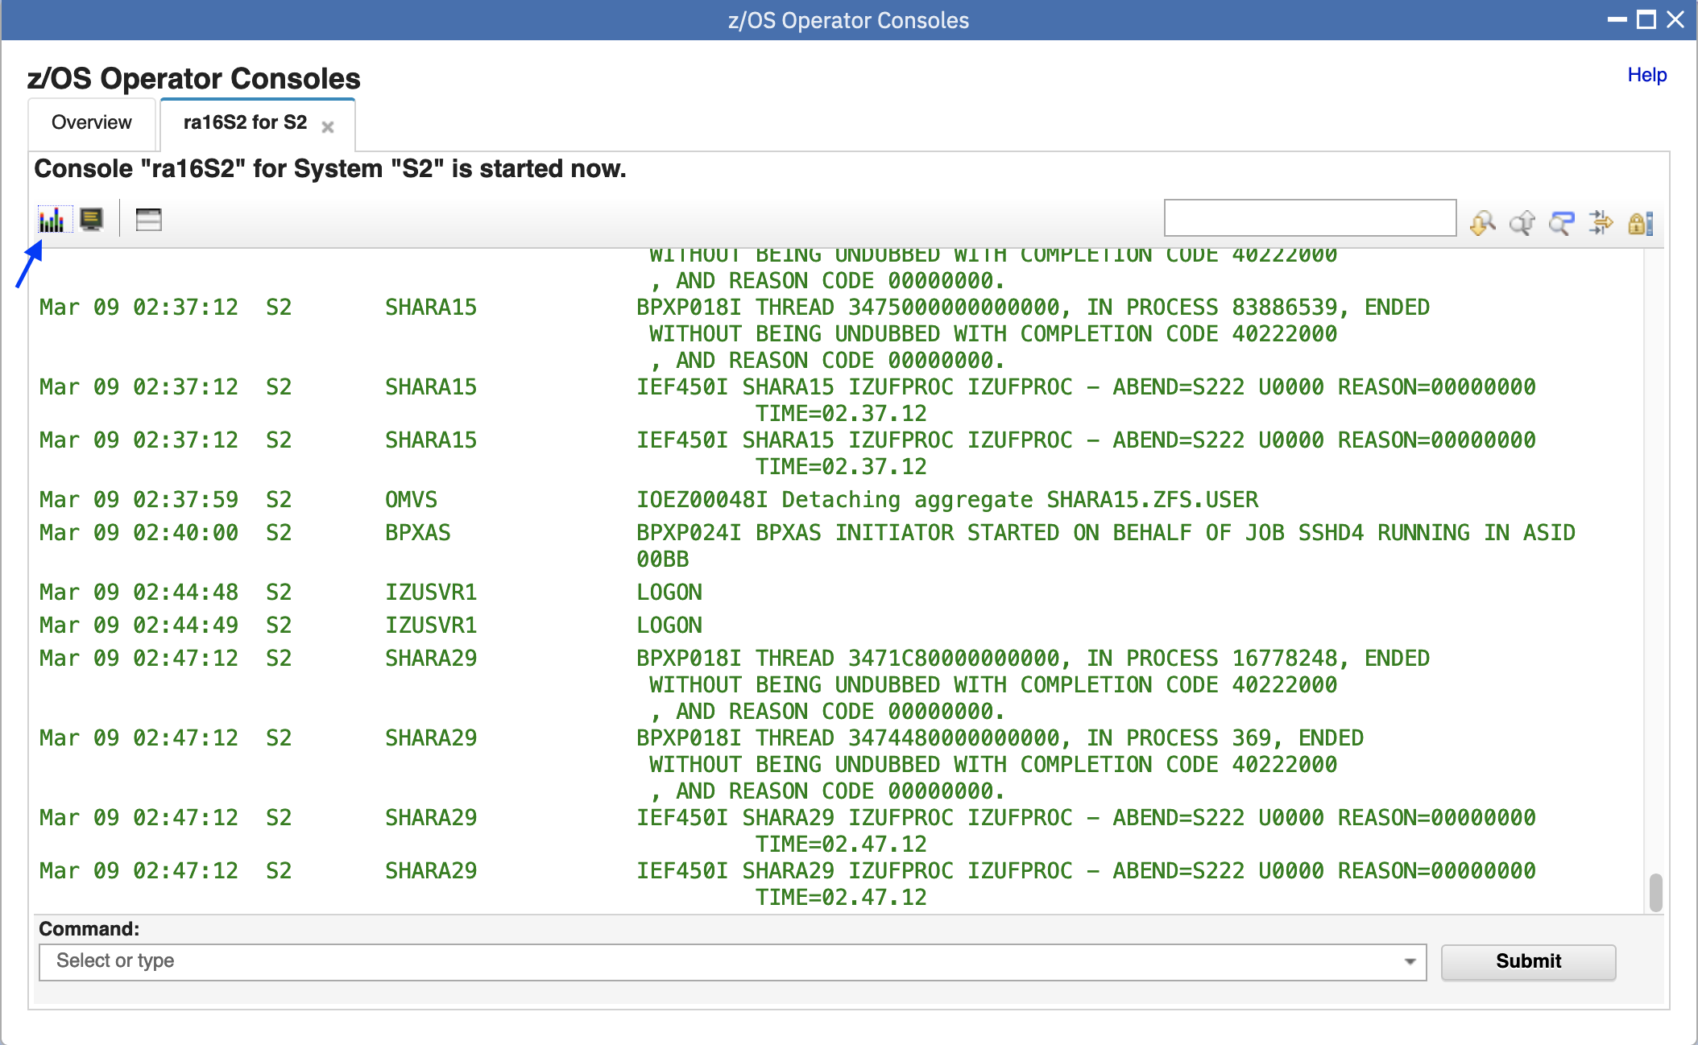

Step 6b: Click Show summary view (same little bar box on the tool bar), the console summary view will then be displayed

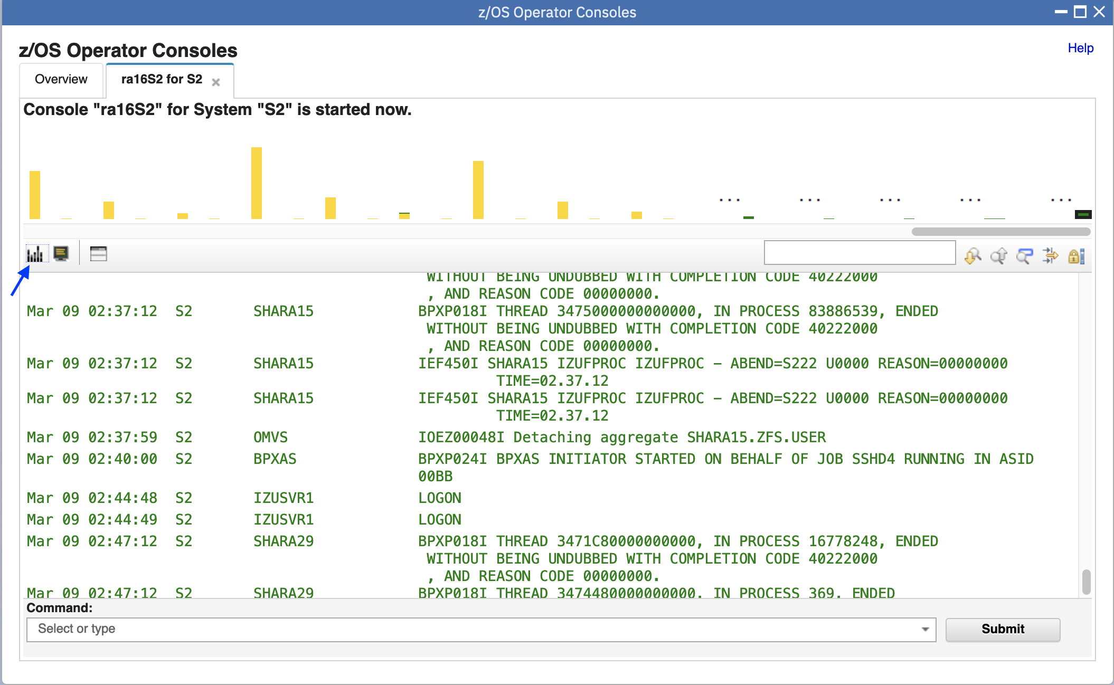

* 1. Show/Hide WTOR and HOLD messages

Step 7a: Click the icon of “Show WTOR and HOLD messages” to display the WTOR/HOLD view. All WTOR messages and HOLD messages that are issued since the console started will be displayed in the separate view.

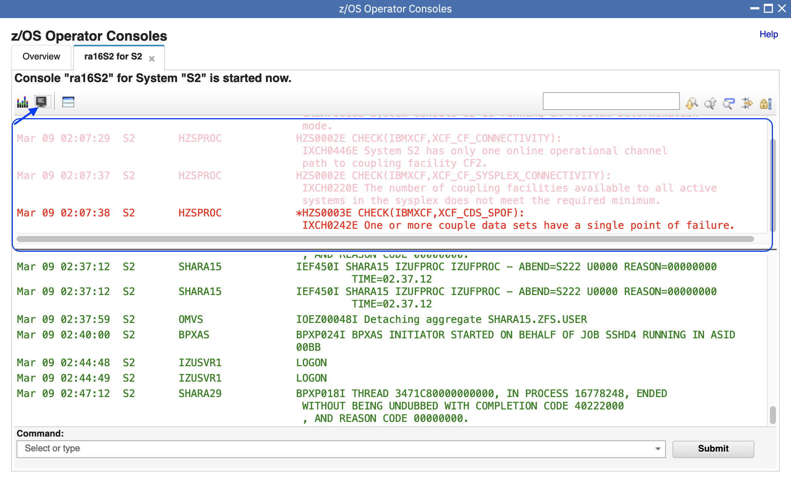

Step 7b: Change layout of WTOR/HOLD message view.

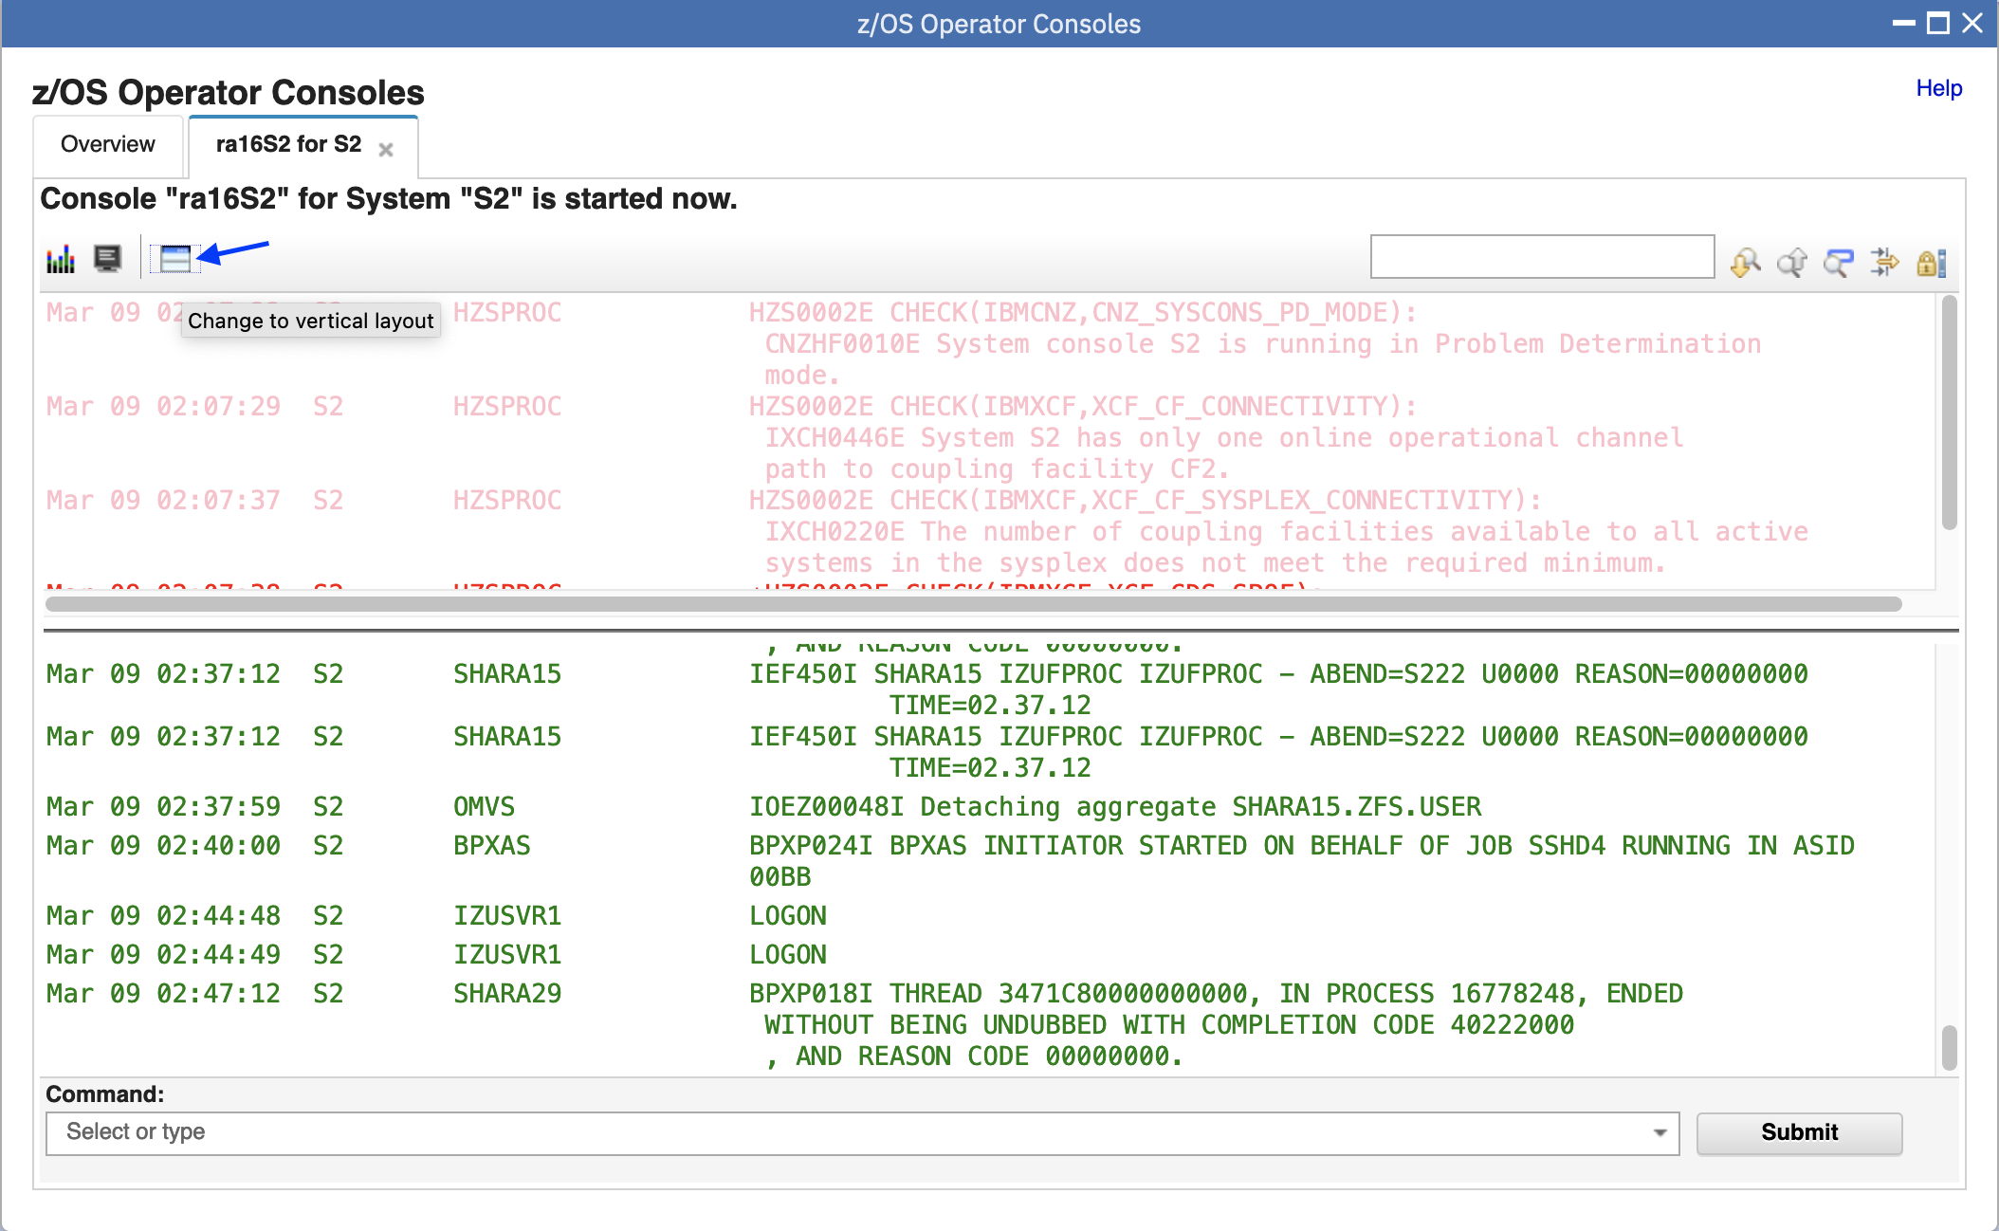

The WTOR/HOLD message view is changed to vertical layout.

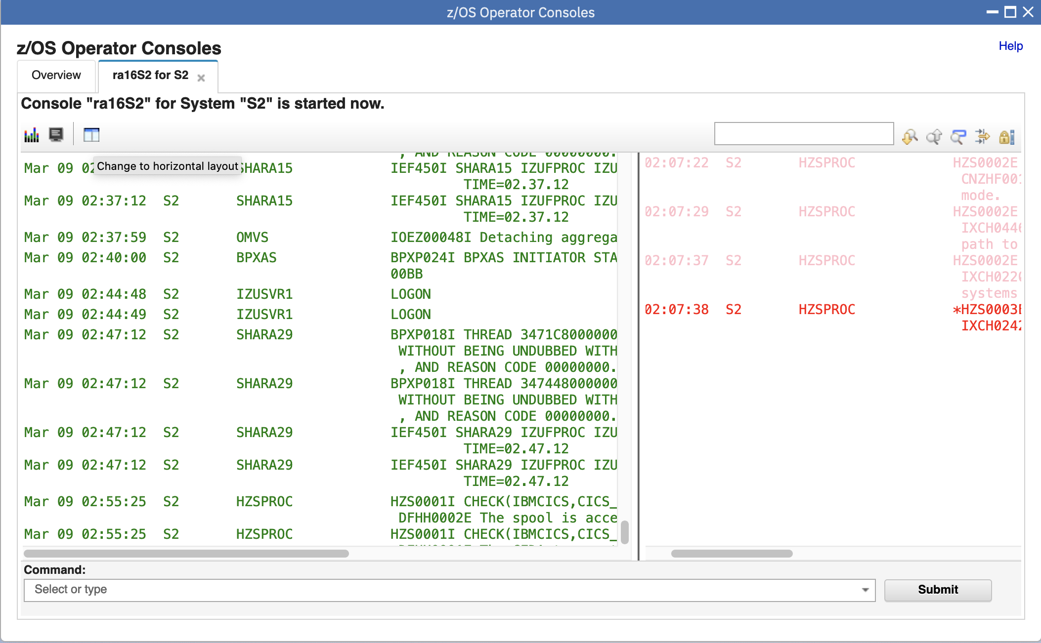

Step 7c: Drag this line to resize windows as you need.

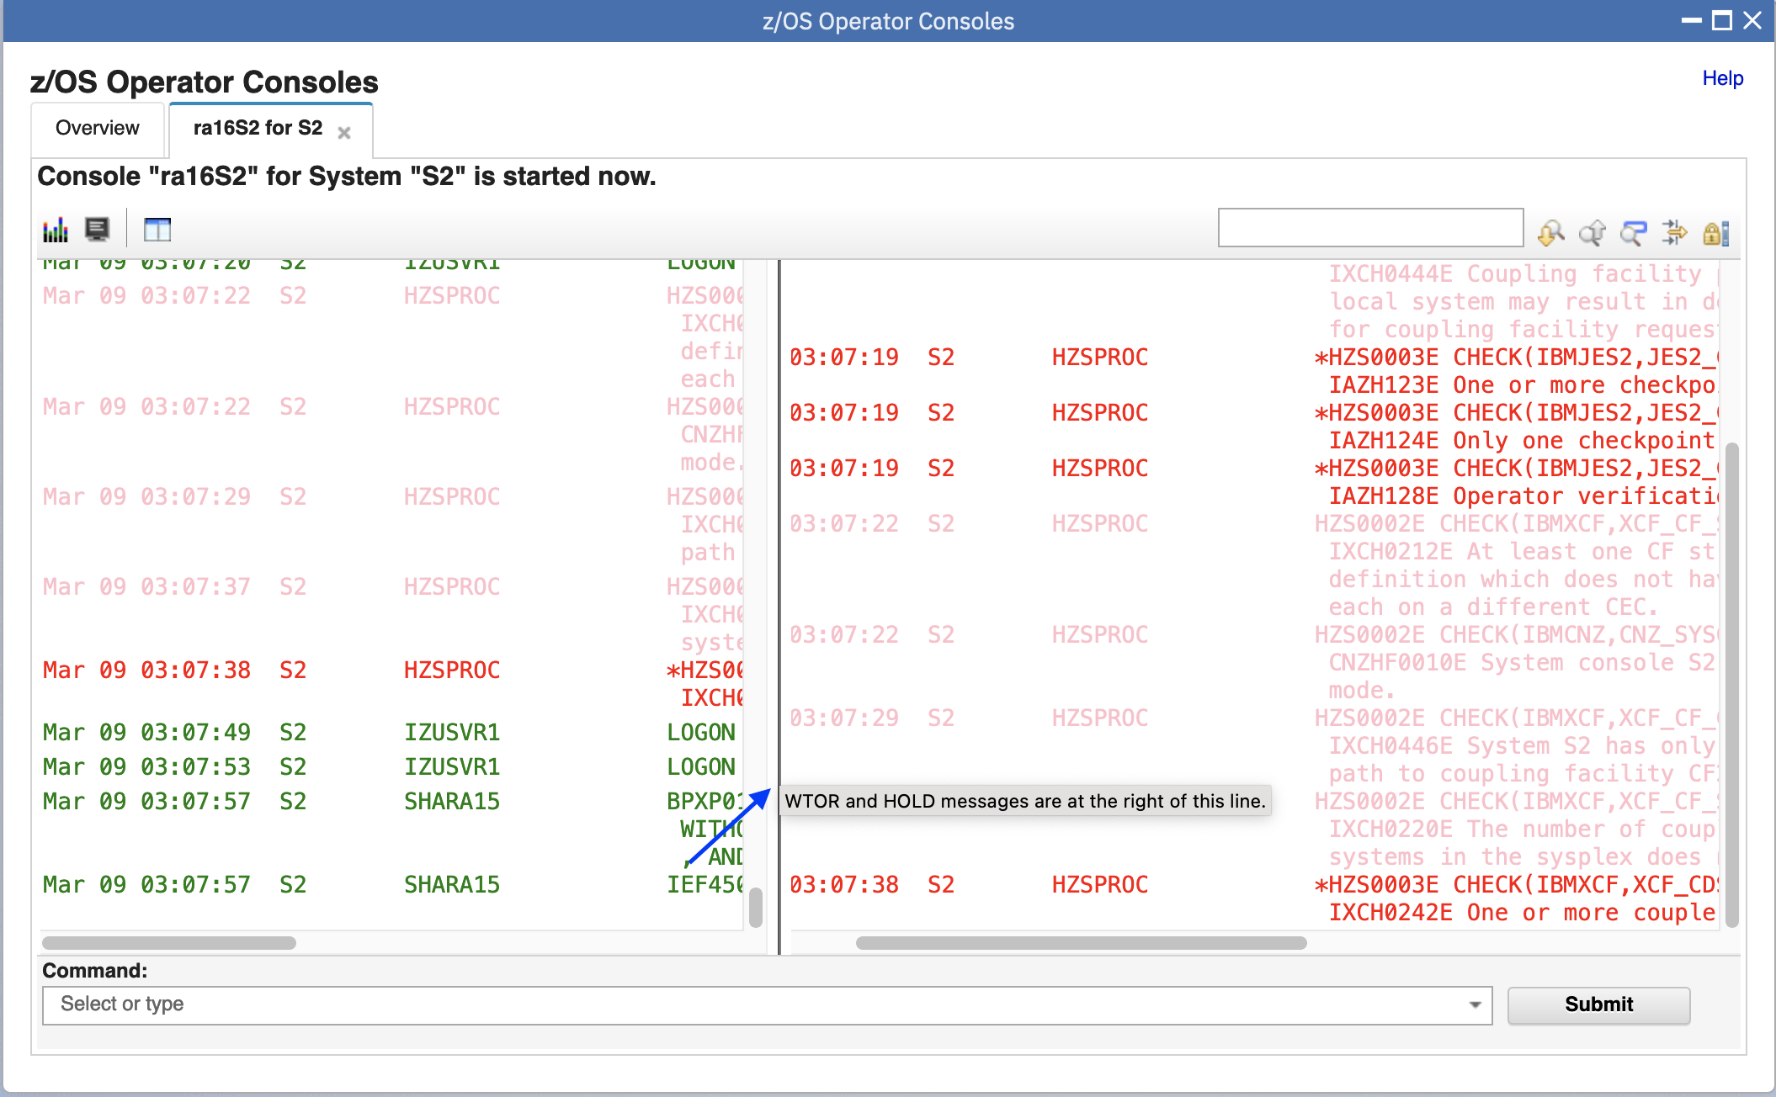

Step 7d: Click the icon of Hide WTOR and HOLD messages, the WTOR/HOLD message view will be hidden.

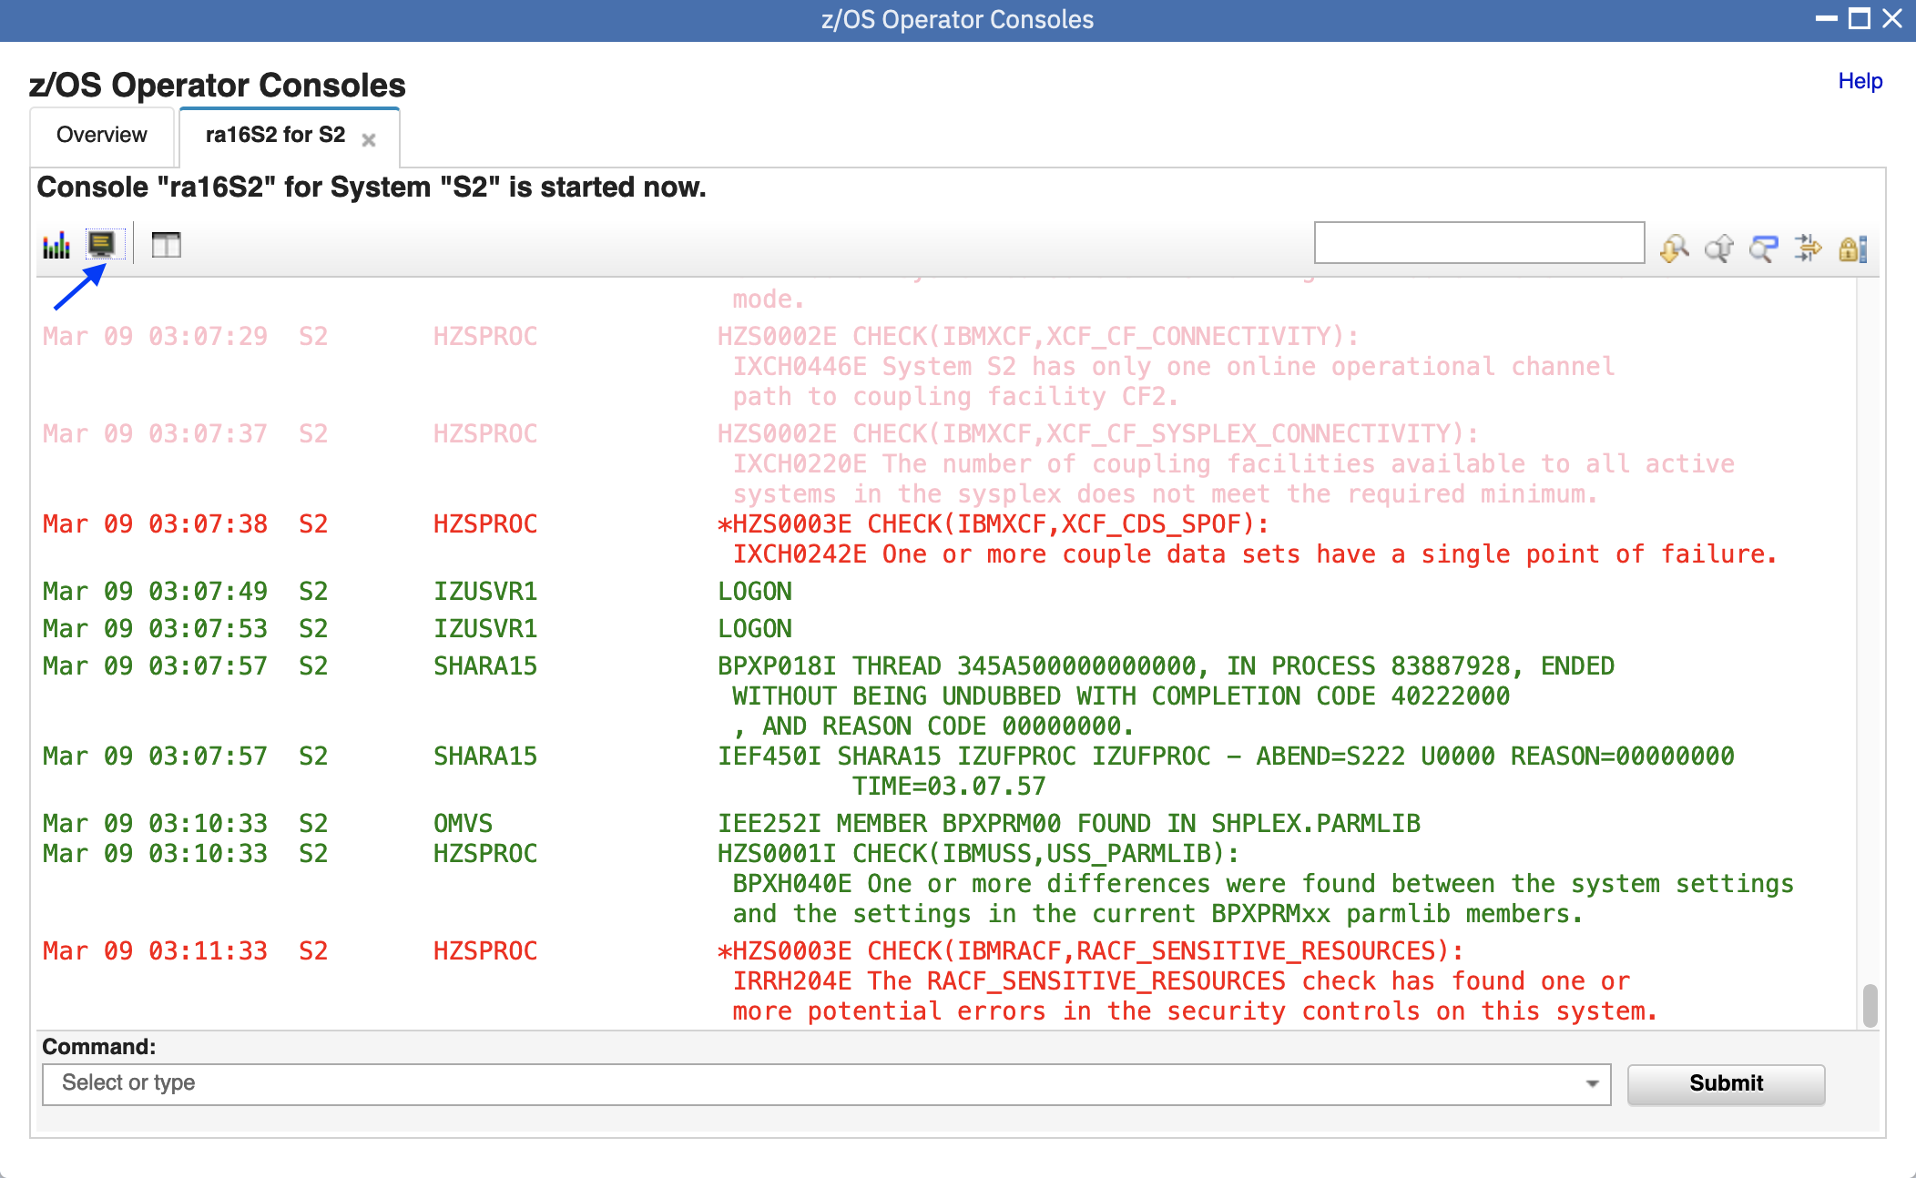

* 1. Enter system commands

Step 8a: Input “D PARMLIB” into the textbox on the bottom, hit enter or click 'Submit' button, the command response will be displayed in the console window.

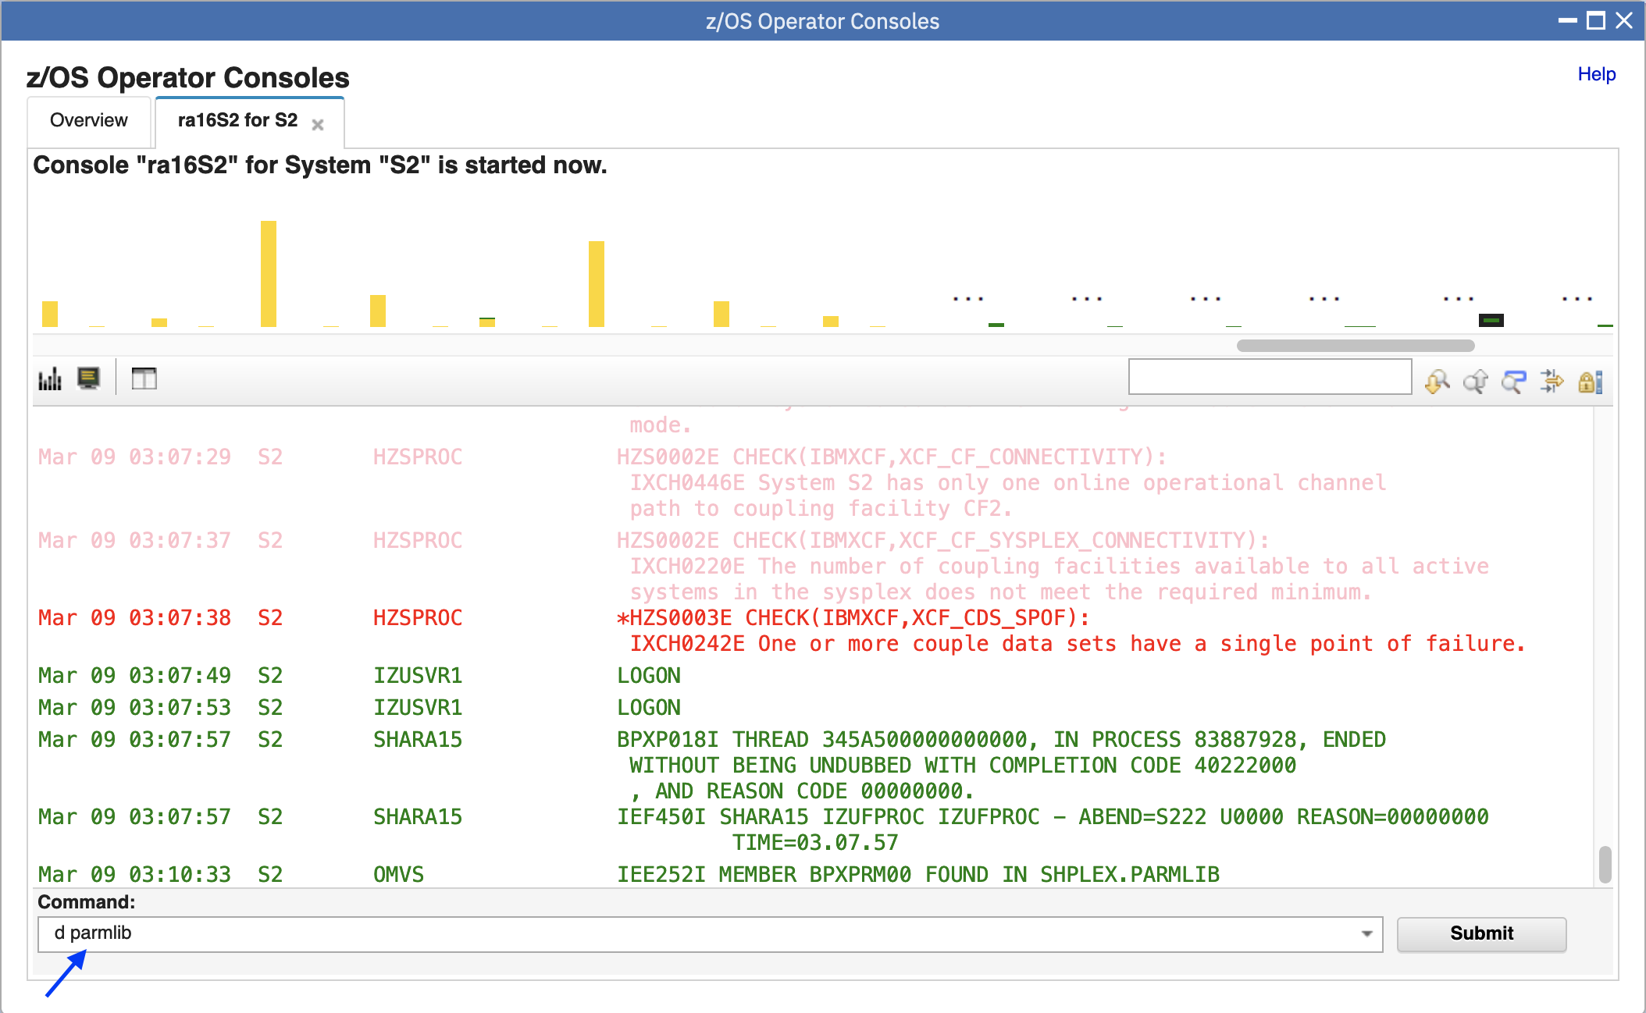

Step 8b: Please be aware that the command and command response may be refreshed after unsolicited messages are received.

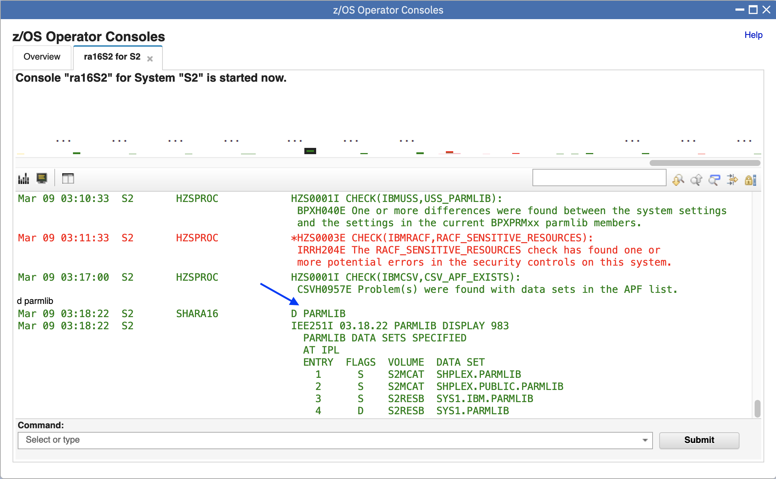

Step 8c: Input “d a,l” into the textbox, click 'Submit' button or press Enter, the command response will be displayed in console window.

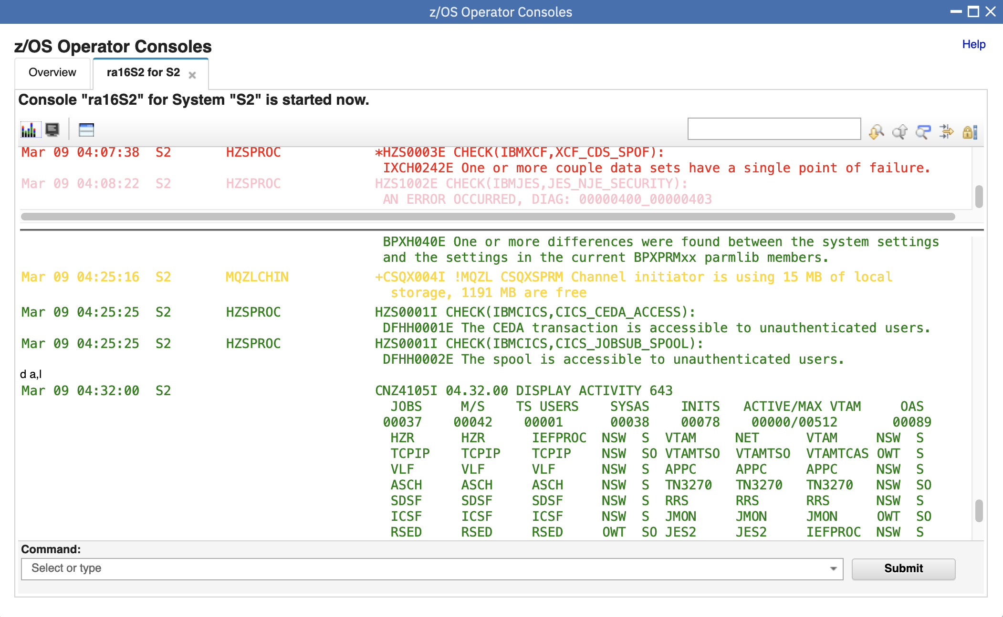

Step 8d: Enter system command "d p" again to trigger the command history "d parmlib"

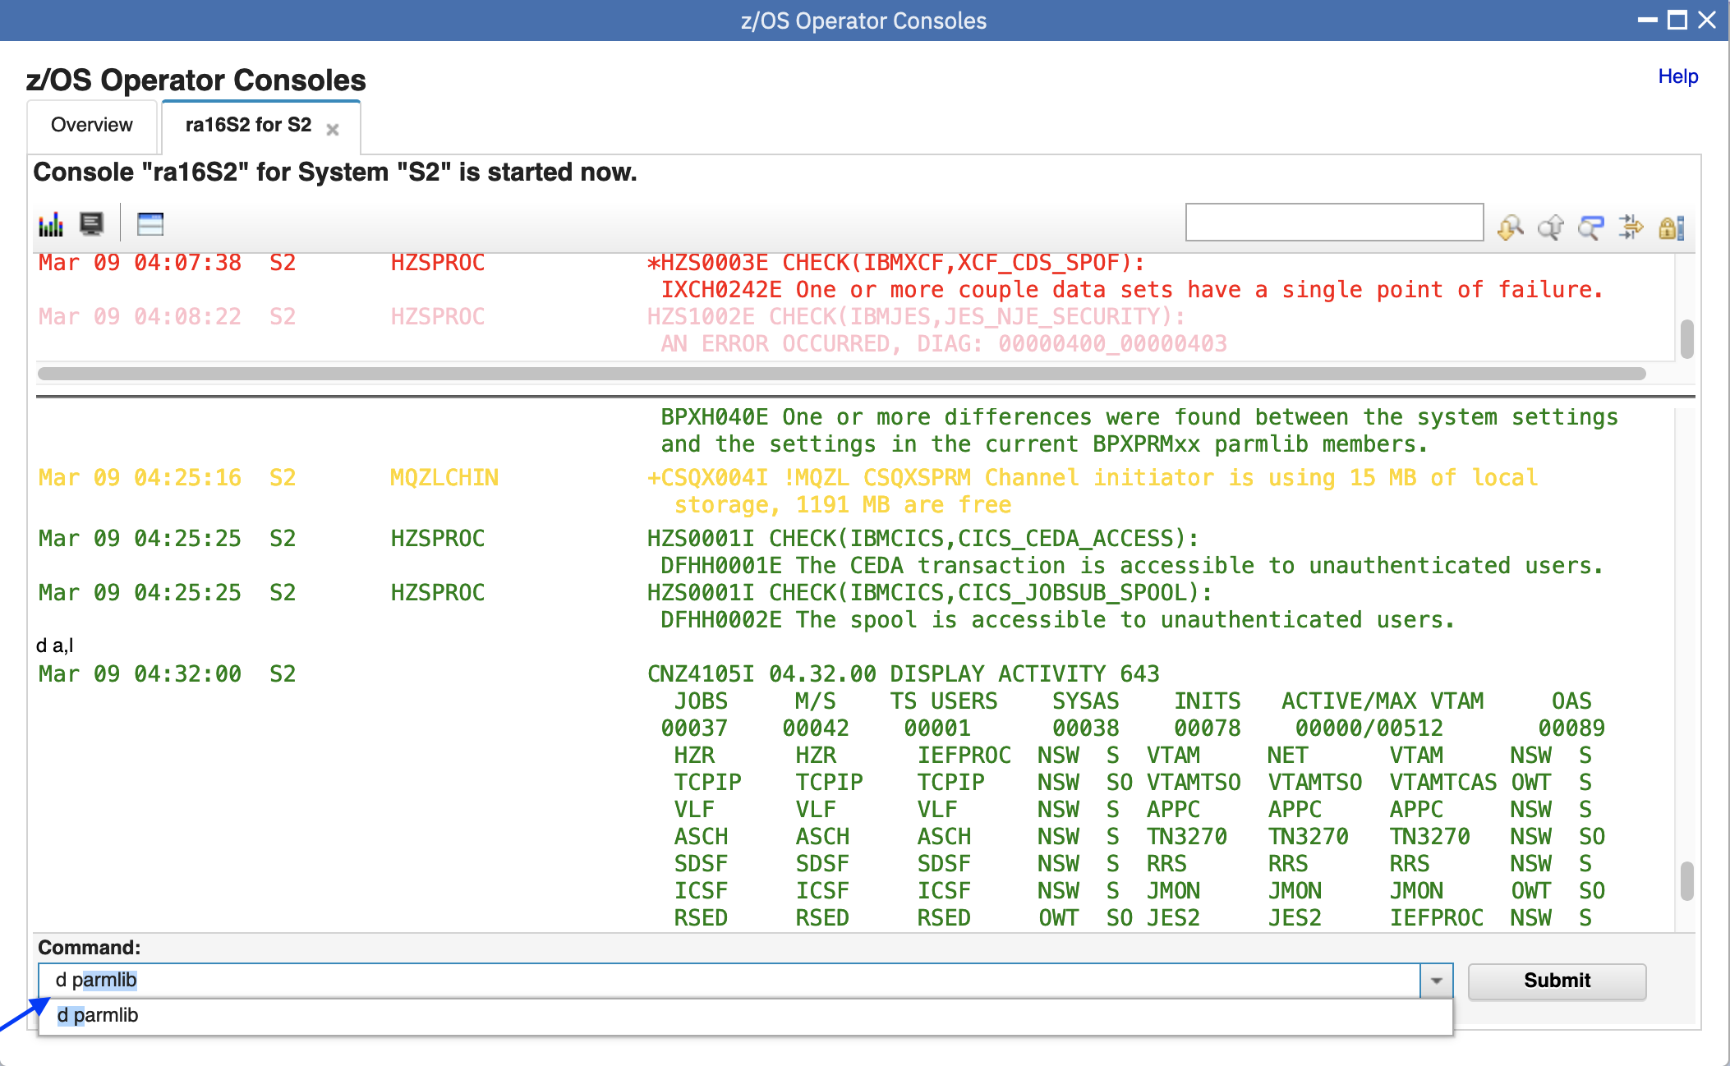

* 1. Lock/Resume console

Step 9a: Click Lock console icon, the console for S2 will be locked, no new messages will be retrieved which could help user to focus on previous messages.

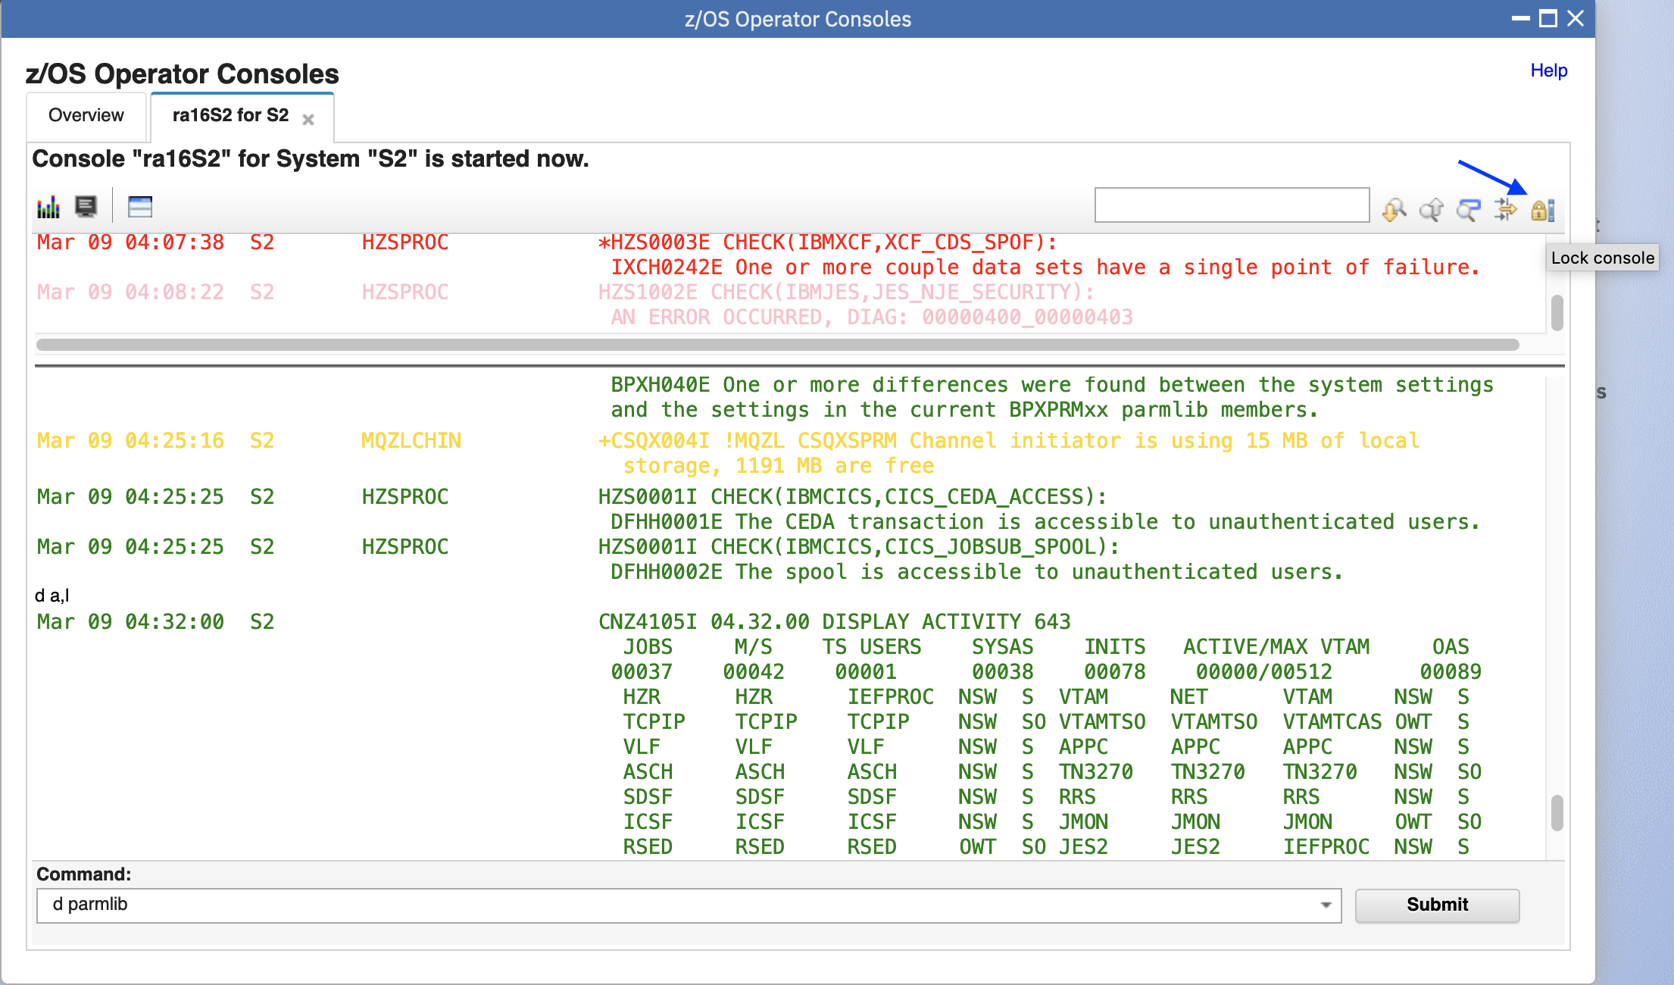

Step 9b: Click Unlock console icon, the console for S2 will be resumed and continue to retrieve new messages.

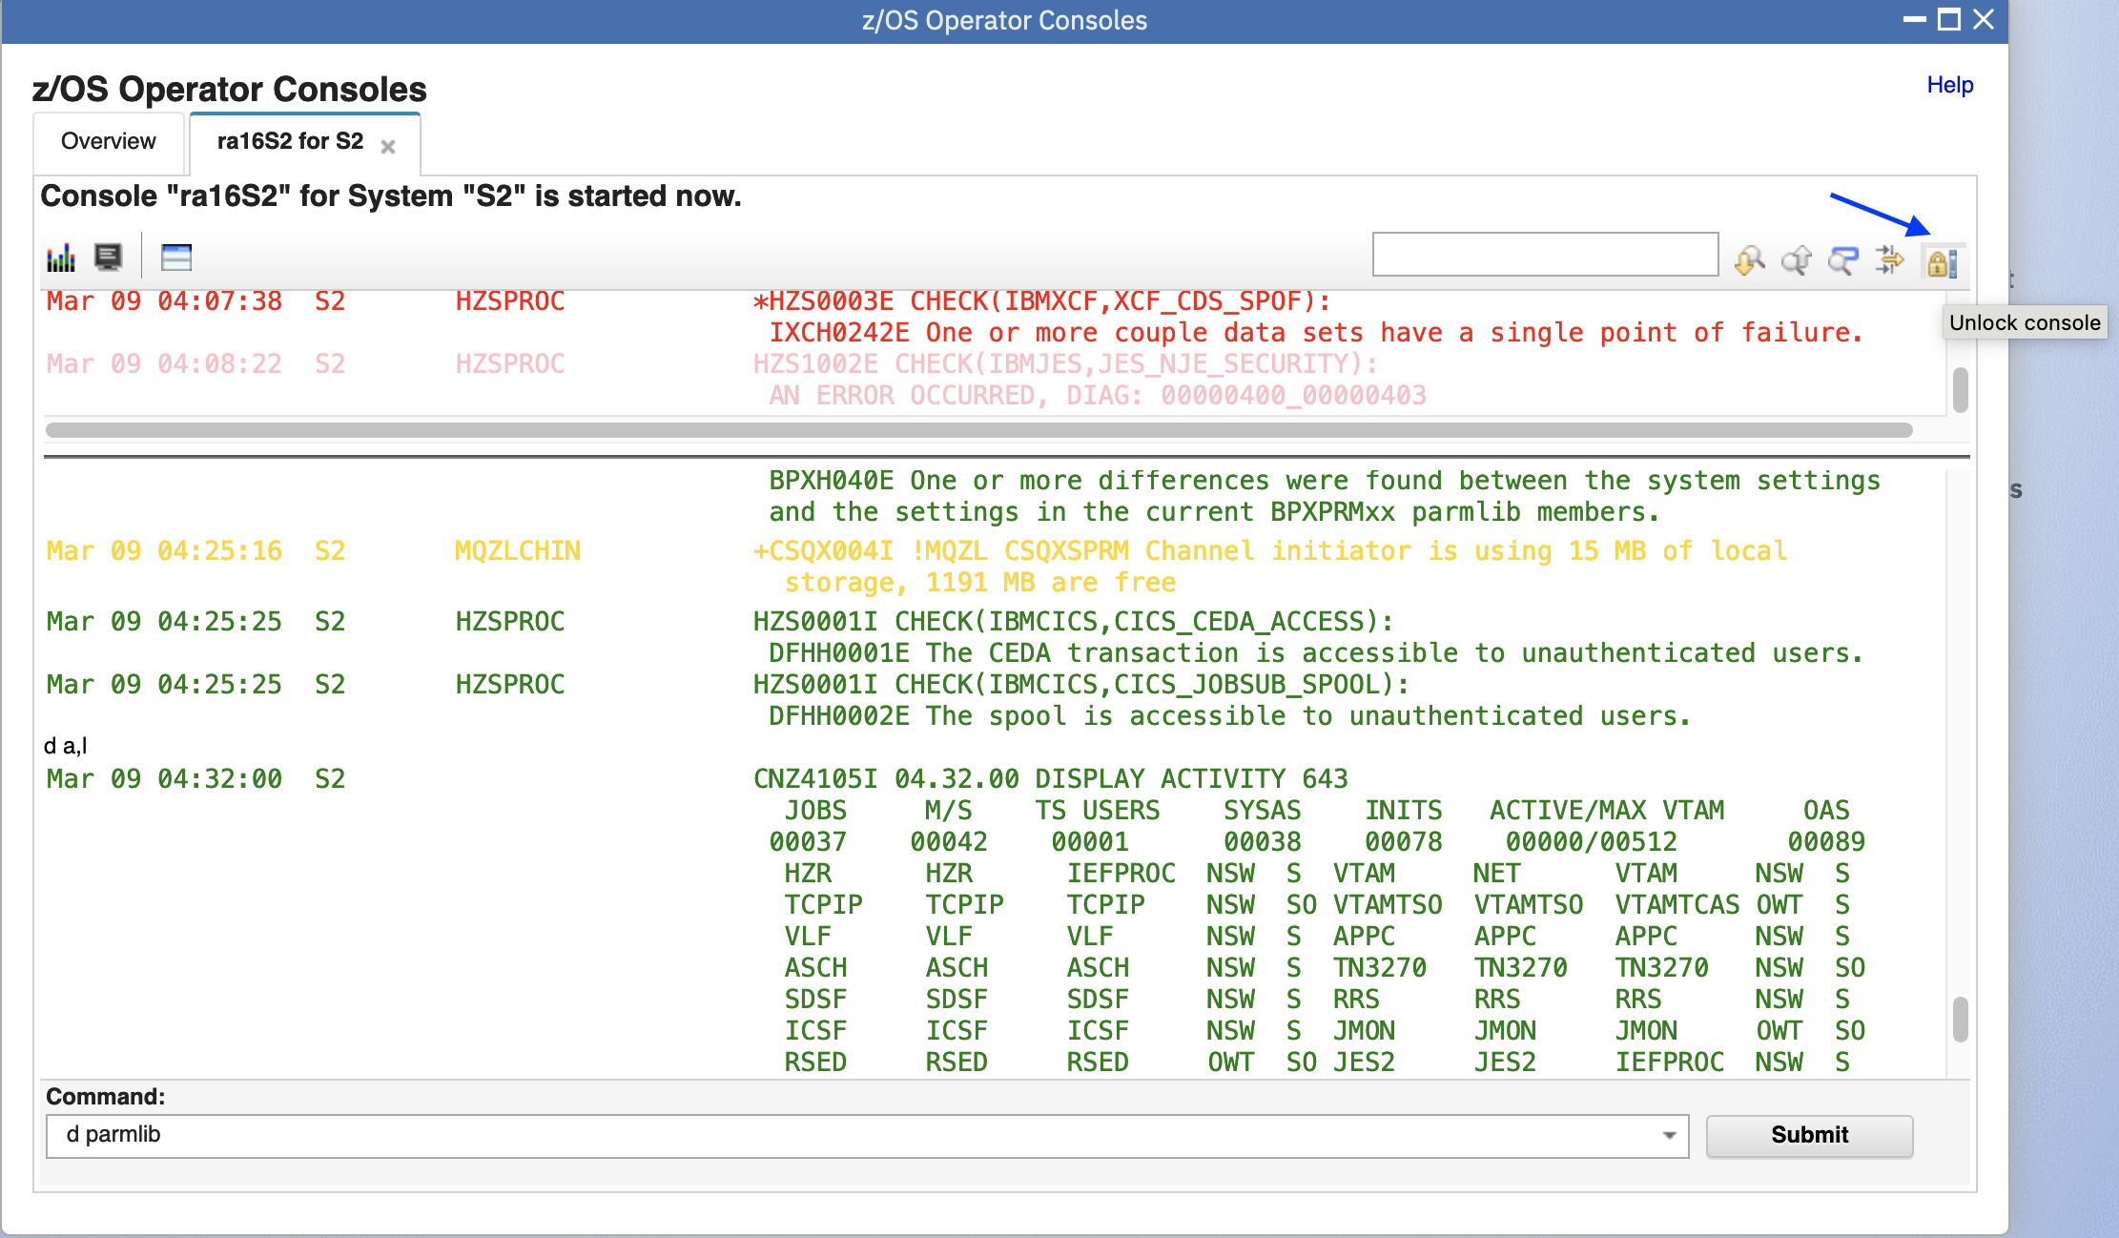

* 1. Search keywords

Step 10a: Input "D PARMLIB" into the Search input box, click Search down icon next to the input box, the "D PARMLIB" will be highlighted in the console window, and the console for S2 will be locked.

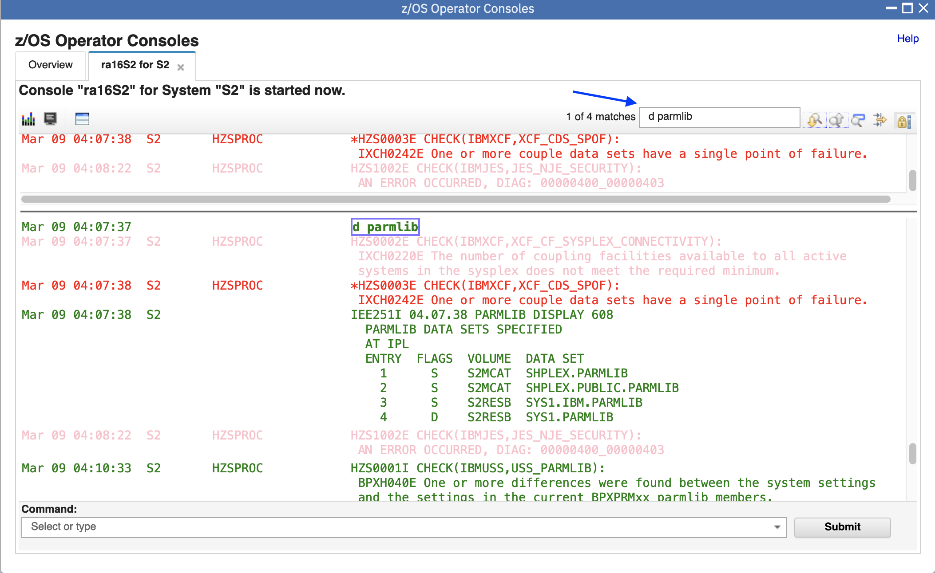

Step 10b: Click Search down icon again, next occurrence will be highlighted. Click Highlight all icon on the tool bar, all of "D PARMLIB" will be highlighted.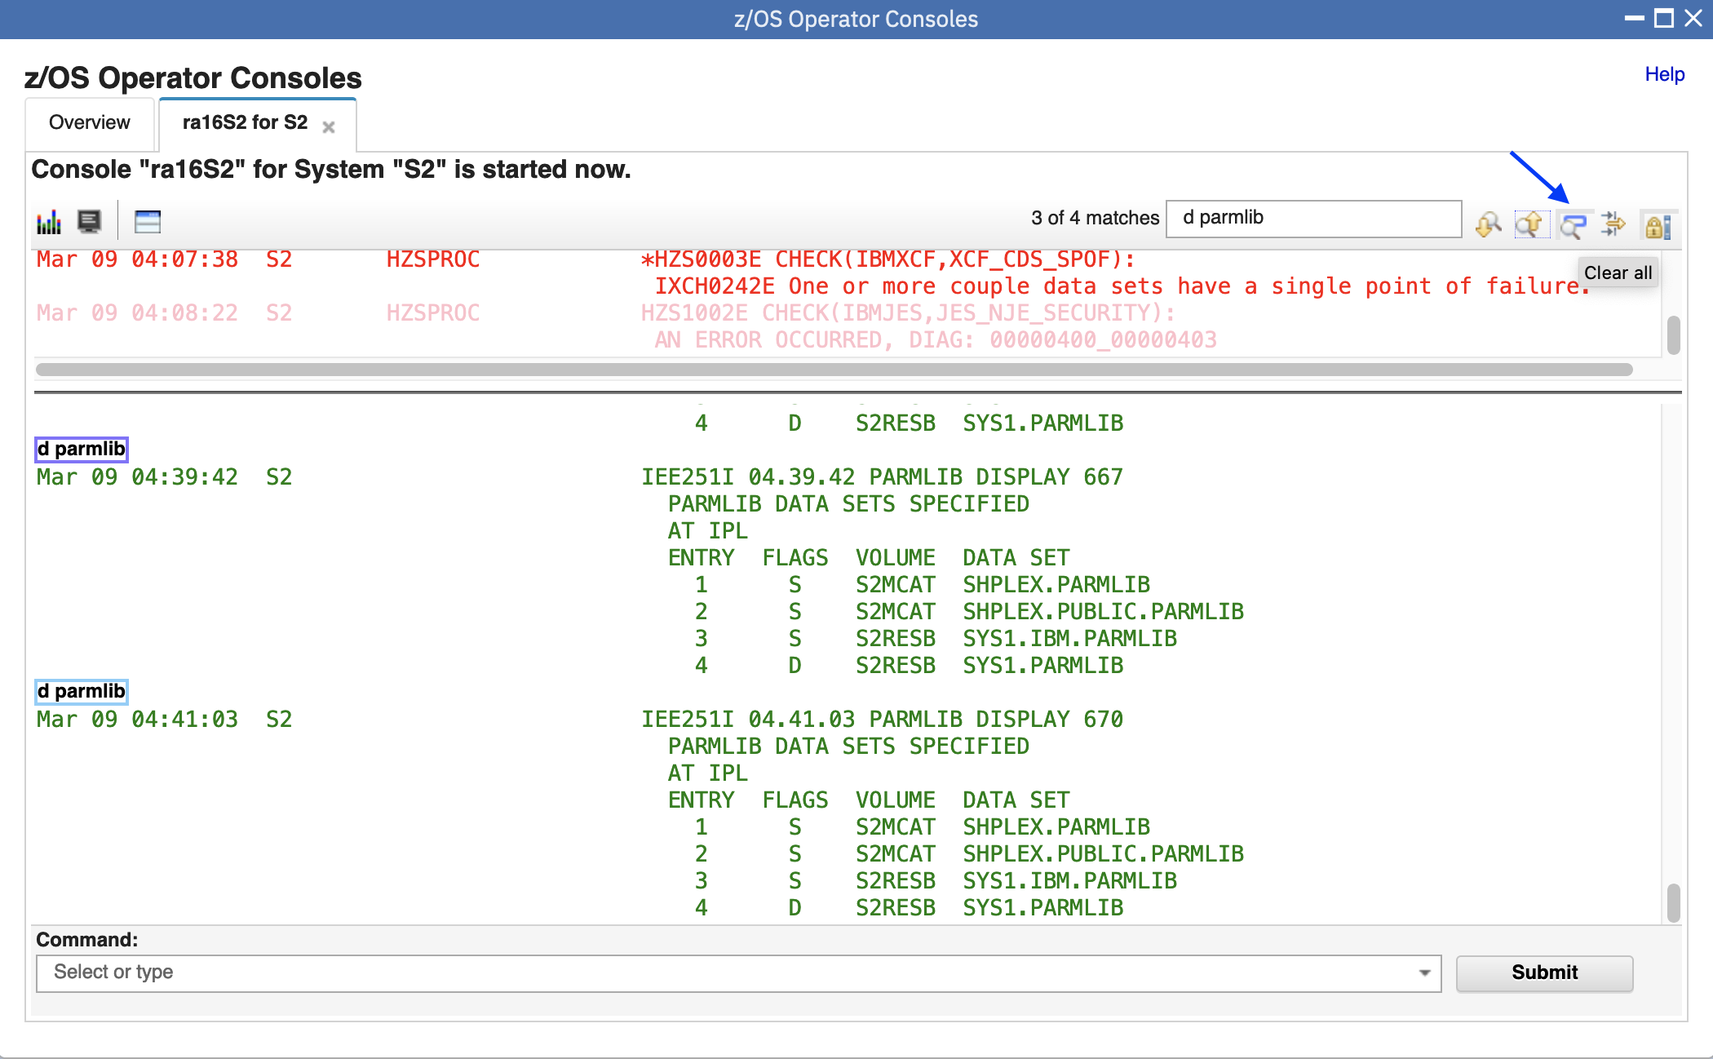 Step 10c: Click Clear all icon (the same icon of Highlight all), all highlighted text will be restored, and Console for S2 will be resumed 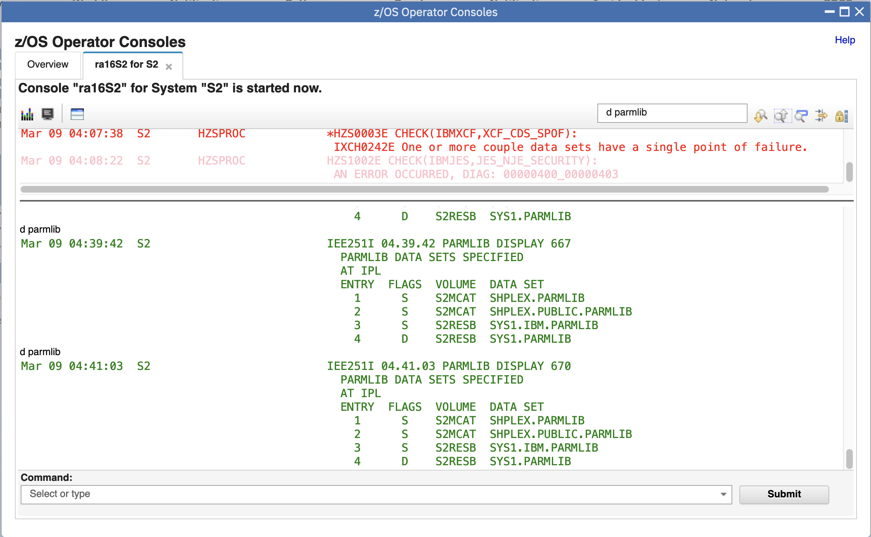

* 1. Filter messages

Step 11a: Click Filter icon, the console for S2 will be locked

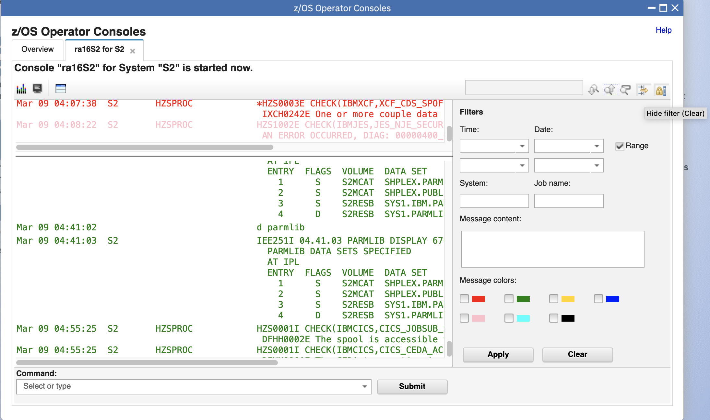

Step 11b: Input “PARMLIB” into the textbox of message content, click Apply button, only messages which contain “PARMLIB” will be displayed in the console window.

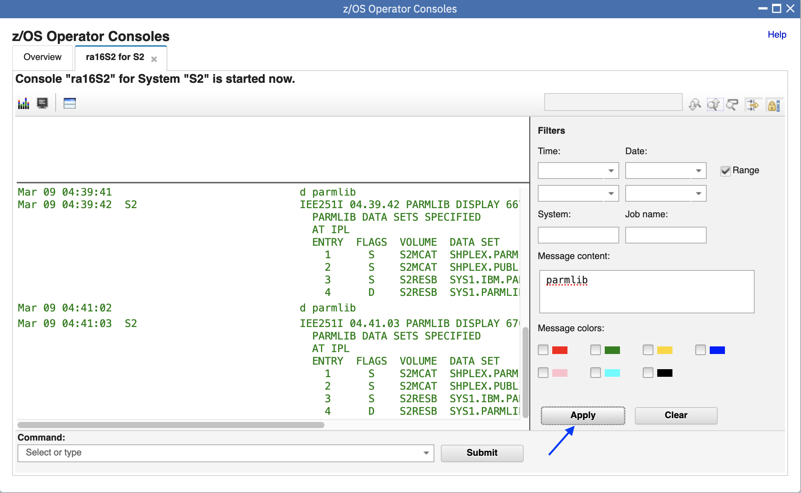

Step 11c: Click Clear button, filters will be cleaned up and all messages will be displayed. 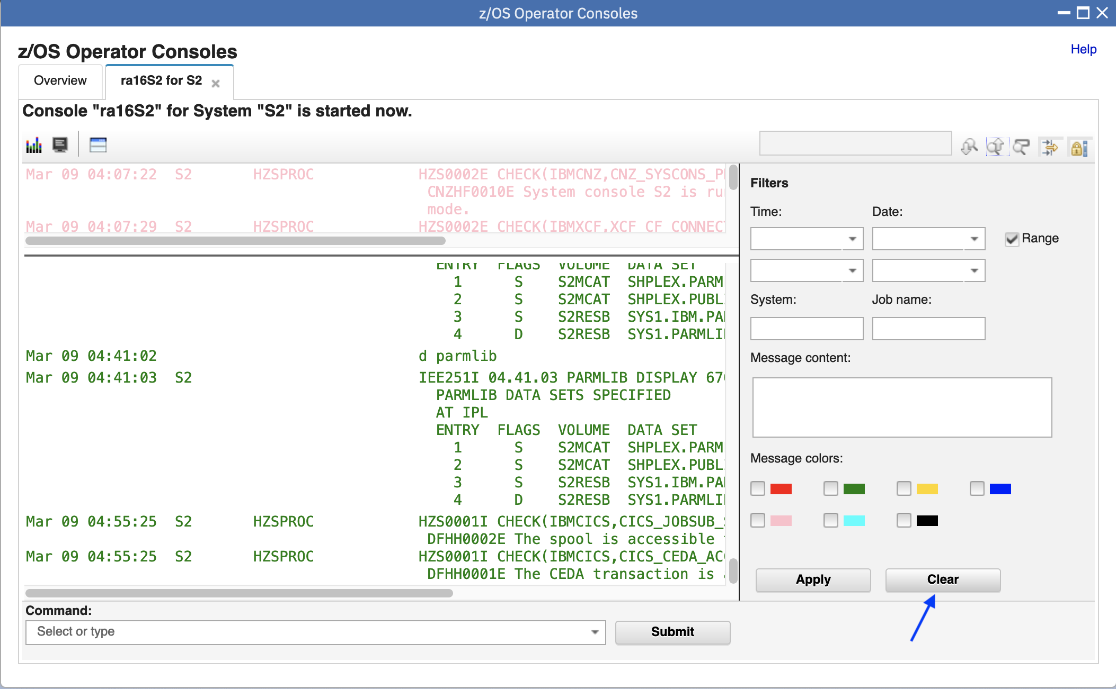

Step 11d: Click Hide filter icon, the console for S2 will be resumed and Filter dialog will disappear. 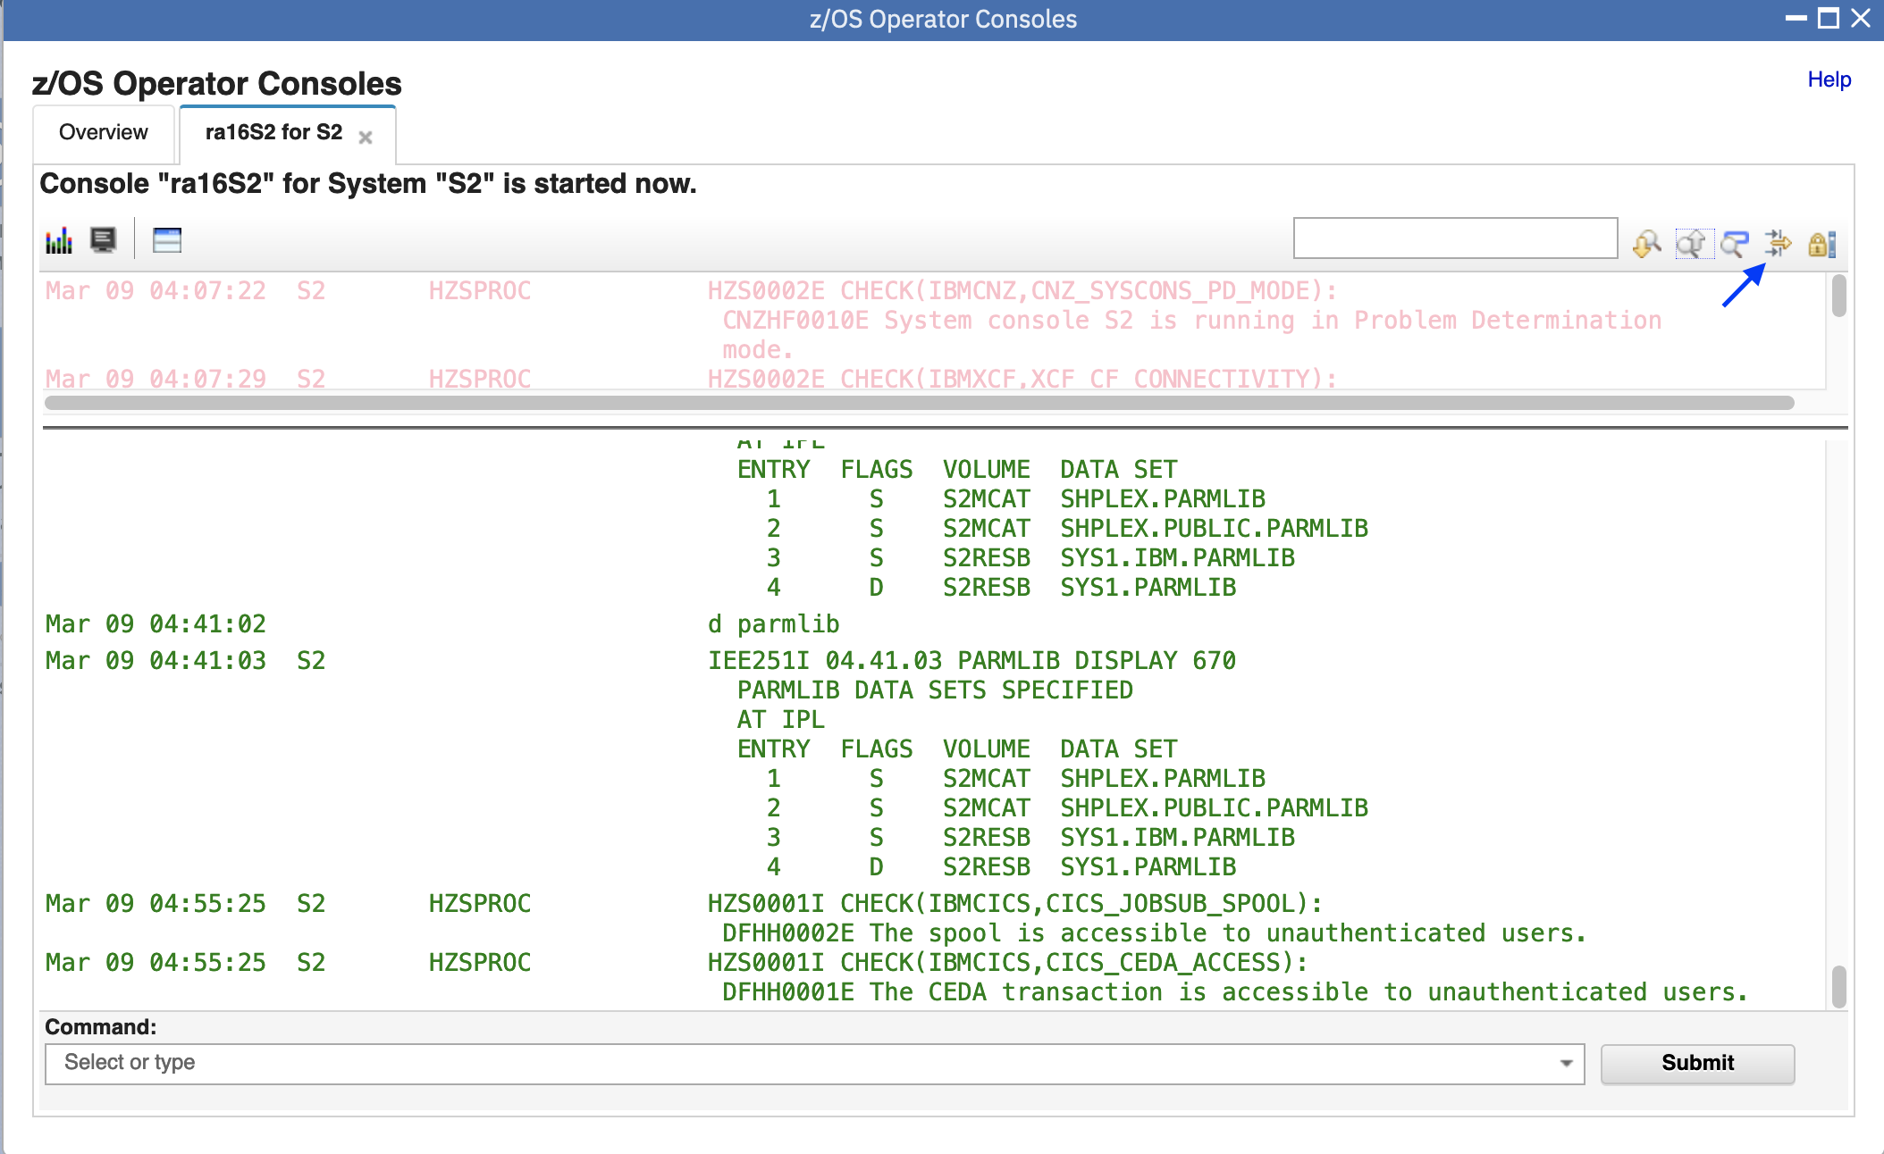

* 1. Retrieve historic messages from SYSLOG

Step 12a: Historic messages are the messages happened before user starts the console in z/OSMF. You can use the UP icon on top of console window to retrieve historic messages from SYSLOG or OPERLOG. Up to 200 messages can be retrieved at a time. (To avoid automatic refresh when new messages come in, suggest to lock the console before you click on the UP icon).

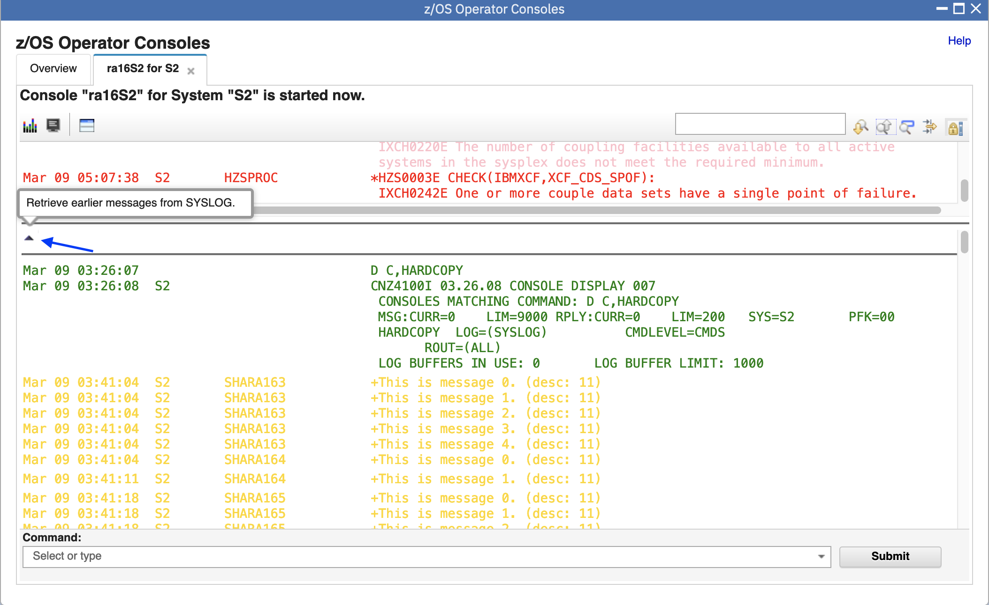

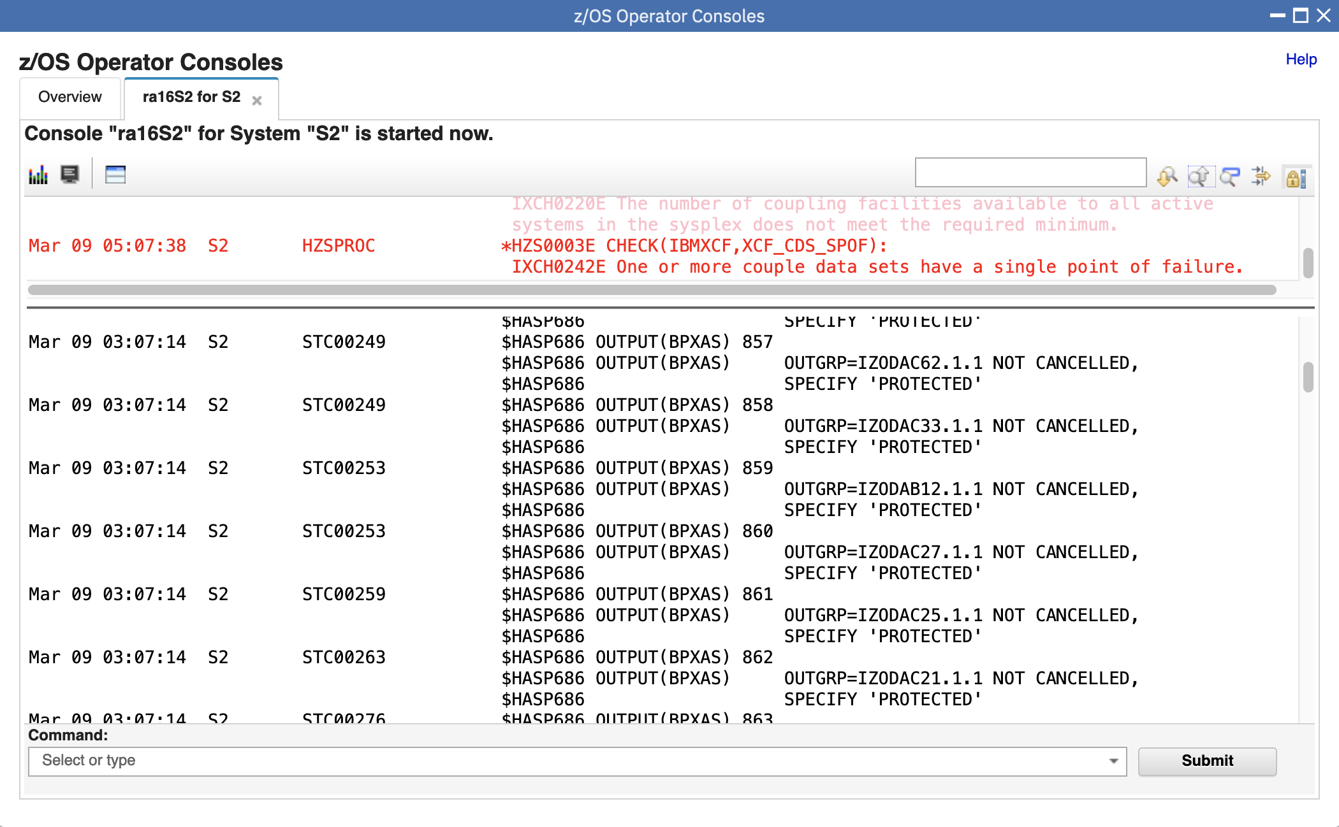

#### End of exercise

## Exercise Review and Wrap-Up

You now know how to use the z/OS Operator Consoles:

* Log on to z/OSMF
* Complete Setup for one system or local sysplex
* Start console and open console panel
* View system messages for a system or local sysplex
* Association between message bar and messages
* Hide/Show summary view
* Show/Hide WTOR and HOLD messages
* Enter system commands
* Lock/Resume console
* Search keywords
* Filter messages
* Retrieve historic messages from SYSLOG

